

Research into optimised and future railway infrastructure

S2R-CFM-IP3-01-2020 Innovation Action

D3.2 – Midterm report, Wheel/rail interaction, simulations and track monitoring

Confidentiality level: CO

**In2Track3 Consortium**

|  |  |  |  |
| --- | --- | --- | --- |
| **No.** | **Participant organisation name** | **Country** | **Acronym** |
| 1 | Trafikverket | SE | TRV |
| 2 | AC2T research GmbH | AT | AC2T |
| 3 | Acciona Construccion SA | ES | ACC |
| 4 | Centro De Estudios De Materiales Y Control De Obra SA | ES | CEM |
| 5 | Finnish Transport Infrastructure Agency | FI | FTA |
| 6 | Fritsch Chiari & Partner Ziviltechniker GmbH | AT | FCP |
| 7 | Getzner Werkstoffe GmbH | AT | GETZ |
| 8 | Hitatchi Rail STS SPA | IT | HIT |
| 9 | Infraestruturas De Portugal SA | PT | IP |
| 10 | Kirchdorfer Fertigteilholding GmbH | AT | KIRCH |
| 11 | Materials Center Leoben Forschung GmbH | AT | MCL |
| 12 | Network Rail | UK | NR |
| 13 | Plasser & Theurer, Export Von Bahnbaumaschinen GmbH | AT | P&T |
| 14 | Prorail BV | NL | PROR |
| 15 | Railenium | FR | RAILEN |
| 16 | SBB | CH | SBB |
| 17 | SNCF Reseau | FR | SNCF-R |
| 18 | Turkiye Cumhuriyeti Delivet Denir Yollari Islemesi Genel Mudurlugu | TR | TCDD |
| 19 | Universidade do Minho | PT | MINHO |
| 20 | Universidade do Porto | PT | PORTO |
| 21 | Universidad Del Pais Vasco/Euskal Herriko Unibersitatea | ES | EHU |
| 22 | Wiener Linien GmbH & Co KG | AT | WL |
| 23 | Virtual Vehicle Research GmbH | AT | VIF |
| 24 | Voestalpine Rail Technology GmbH | AT | VART |
| 25 | Voestalpine Railway Systems GmbH | AT | VARS |
| 26 | ÖBB-Infrastruktur AG | AT | ÖBB |

Project information

DISCLAIMER AND ACKNOWLEDGEMENT

This project has received funding from the European Union's Horizon 2020 Programme Research and Innovation action under Grant Agreement No 101012456.

This document reflects the views of the author(s) and does not necessarily reflect the views or policy of the European Commission. Whilst efforts have been made to ensure the accuracy and completeness of this document, the In2Track3 consortium shall not be liable for any errors or omissions, however caused.

|  |  |  |
| --- | --- | --- |
| Document history | | |
| **Revision** | **Date** | **Description** |
| 1 | 2020-11-17 | Skeleton |
|  | 2021-03-12 | Revised skeleton |
|  |  |  |

|  |  |  |
| --- | --- | --- |
| Report contributors | | |
| **Name** | **Beneficiary Short Name** | **Details of contribution** |
| Anders Ekberg | TRV | Skeleton |
|  |  |  |
|  |  |  |
|  |  |  |
|  |  |  |

**TABLE OF CONTENTS**

Executive summary 4

1 Track Design T3.1 (NR, TRV, ACC, CEM, PORTO, GETZ, TCDD, SNCF-R, VART, RAILEN, SBB, M1-M33) 5

2 Track maintenance T3.2 (TRV, P&T, WL, NR, VART, RAILEN, AC2T, M1-M33) 6

3 Wheel/rail interaction T3.3 (TRV, SBB, AC2T, FCP, PORTO, M1-M33) 7

3.1 Wheel/rail management ST 3.3.1 (CTH, LTU and KTH for TRV, SBB, AC2T, M1-M33) 7

3.1.1 Investigate a method to resolve vehicle running instability caused by poor wheel-rail interfaces 7

3.1.2 Define stability robust wheel and rail profiles 8

3.1.3 Wheel tread geometry limits 9

3.1.4 Influence of out-of-round wheels on probability of rail breaks 10

3.1.5 Influence of wheel tread characteristics on operational lives of rail and running gear 11

3.1.6 Performance requirements of friction modifiers 12

3.1.7 Impact of laser cladding and heat treatment on the wheel/rail interface 14

3.2 Noise and vibration ST 3.3.2 (UoSo for NR, CTH for TRV, SBB, FCP, PORTO, M1-M33) 14

3.2.1 Reduced noise and vibrations from slab track 15

3.2.2 Predict and mitigate curve squeal 16

Also 3.2.2 Predict and mitigate curve squeal 17

3.2.3 Reduce noise after rail machining 18

3.2.4 Vibration performance of track systems 19

3.2.5 Mitigation of noise and vibrations 21

3.2.6 Mitigation of ground-borne vibrations 23

4 Simulations and track monitoring T 3.4 (TUD for PROR, TRV, VIF, RAILEN, SNCF-R, M1-M33) 25

4.1 Simulations, whole system approach and hybrid testing ST 3.4.1 (VIF, CTH/TRV, M1-M33) 25

4.1.1 Track information model 25

4.1.2 Evolution and degradation of ground rail in digital twin 28

4.1.3 Whole system modelling and hybrid testing methodology 30

4.2 Track and component monitoring ST 3.4.2 (TUD for PROR, CTH and LTU for TRV, UoB for NR, RAILEN, SNCF-R, M1-M33) 31

4.2.1 Track status assessment 31

4.2.2 Assessment of RCF detection data 32

4.2.3 System prototype demonstration of RCF detection 32

4.2.4 Friction level sensor 35

4.2.5 Train-borne tribometer 36

4.2.6 Data mining to identify performance critical parameters 38

4.2.7 Influence of track stiffness variations 40

4.2.8 Embedded sensors for prognostics and health management 42

4.2.9 Assessment of renovation critical areas 43

5 Integration & collaboration with SHIFT2RAIL and other initiatives T 3.5 (TRV, M1-M36) 45

6 Heading 1 46

6.1 Heading 2 46

6.1.1 Heading 3 46

# Executive summary

# Track Design T3.1 (NR, TRV, ACC, CEM, PORTO, GETZ, TCDD, SNCF-R, VART, RAILEN, SBB, M1-M33)

Please refer to D3.1

# Track maintenance T3.2 (TRV, P&T, WL, NR, VART, RAILEN, AC2T, M1-M33)

Please refer to D3.1

# Wheel/rail interaction T3.3 (TRV, SBB, AC2T, FCP, PORTO, M1-M33)

**Responsible:** TRV (Person)

Task 3.3 deals with the system of wheel/rail interaction in terms of increased the performance by improve safety, decrease noise pollutions and improve ride comfort on track to enhance the credibility of railway in general but also the performance of the system.

Task 3.3 will improve the performance of the system wheel/rail by improving the profiles of wheel and rail and reduce the pollution of noise and vibration. Improvements in the wheel/rail interface will improve credibility of the rail transport and also support further sustainable transport in Europe.

## Wheel/rail management ST 3.3.1 (CTH, LTU and KTH for TRV, SBB, AC2T, M1-M33)

**Responsible:** TRV (Person)

### Investigate a method to resolve vehicle running instability caused by poor wheel-rail interfaces

Investigate a method to resolve vehicle running instability caused by poor wheel-rail interfaces. The work is mainly based on vehicle-track dynamic simulations, but the proposed method is intended for condition monitoring through measured accelerations onboard in-service vehicles.

#### Responsible partner: PARTNER (Persons)

KTH for TRV (Mats Berg)

#### Background and objectives

The dynamic behaviour of the vehicle-track system is a key factor for the overall system performance. A crucial part of this behaviour is the condition of the corresponding wheel-rail interfaces. Vehicle running instability is a system malfunction that often originates from poor wheel-rail interfaces, including tight track gauge, as the vehicle is running at fairly high speed on straight track or in large-radius curves. The present work is a continuation of the work by Kulkarni et al. in IN2TRACK-2, see its Deliverable D3.3 and a manuscript submitted for international journal publication. The focus is on the wheel-rail interface (nominal and worn profiles) and how this profile match, together with the actual track gauge, will affect the equivalent conicity and associated parameters. If the wheel-rail interaction is the reason for running instability, the objective is to identify the root cause: wheel profile, rail profile or track gauge.

#### Approach

The investigation should mainly be carried out by dynamic vehicle-track simulations supported by measured wheel and rail profiles as well as measured track irregularities (including track gauge). Based on carbody, bogie frame and axlebox accelerations a method, or algorithm, is being developed to detect vehicle running instability and the root cause for this malfunction, also considering the possibility of vehicle suspension issues being the root cause. Together with efforts in other projects the algorithm should be evaluated during vehicle-based condition monitoring of vehicle-track interaction through in-service trains with proper measurement equipment. The key candidate for such measurements is SJ’s X2000 vehicles, already being equipped with triaxial accelerometers at the axleboxes etc, when running on some selected sections on the Swedish mainlines. In practice, vehicle running instability issues should be quickly resolved and the most proper maintenance action carried out. This action could be on the vehicle (wheel), track (rail & gauge) or both. It is also important to identify which vehicles and/or which track sections are in need for maintenance. The methodology and algorithm outlined above should support the quick resolution of vehicle running instability originating from the wheel-rail interface.

#### Results

Xxx

#### Maturity, remaining research and suggestions for implementation

Xxxx

#### Appendices

3.1.1a Jessop, Casey, and Johan Ahlström. 2019. “Friction between pearlitic steel surfaces.” *Wear* 432–433: 9 pp.

#### References

IN2TRACK-2. 2021. Deliverable D3.3.

Kulkarni, R., Qazizadeh, A., Berg, M., Dirks, B., and Persson, I. “Investigating the effect of the equivalent conicity function’s nonlinearity on the dynamic behaviour of a rail vehicle under typical service conditions.”, submitted to *Vehicle System Dynamics*.

References must be according to Chicago style using author–date referencing style. The style of referencing is extensively detailed in https://libguides.williams.edu/citing/chicago-author-date and https://www.chicagomanualofstyle.org/tools_citationguide/citation-guide-2.html

#### Data to be managed

Description of data to be managed:

Responsible for storage:

Availability and restrictions:

### Define stability robust wheel and rail profiles

Define stable wheel and rail profiles that can support good vehicle-track system performance over substantial time, manifested by long vehicle running distance and high MGT volumes on track before maintenance is needed.

#### Responsible partner: PARTNER (Persons)

KTH for TRV (Mats Berg)

#### Background and objectives

The shape of wheel and rail profiles are changing more or less over time due to the wheel-rail contacts and associated forces and sliding motions (creepages) resulting in wear. Ideally the nominal (initial) profiles do not wear much and the still existing wear is fairly well distributed along the profiles so that the profile shapes do not alter much during the operation. In this way an initially optimized vehicle-track system with respect to dynamic performance would have a low deterioration rate giving better ride comfort, less running instability and reduced maintenance costs. However, the choice of such initial profiles is challenging due to mixed operational conditions including for instance different vehicle types on the same railway line and different railway lines operated by the same vehicle type. Wheel reprofiling and rail grinding/milling do also “interfere” with the “natural” wheel-rail contacts. The objective is mainly to develop a possible stable wheel profile, acknowledging the key role of the rail profiles.

#### Approach

The KTH work, given a limited budget, is focused on studying the development of wheel and rail profile changes over time based on existing measurements on selected vehicles and railway lines. Such measured profiles are to be provided by a few train operators and by Trafikverket. Based on trends in wear and profile changes, candidate profiles are to be selected. Further supported by some vehicle-track dynamic simulations, a final wheel profile candidate should be subjected to long-term tests through regular service of a selected vehicle and railway line.

The approach needs to be further discussed with non-KTH co-workers and train operators, not formally being part of IN2TRACK-3 but supported through a national (Swedish) project.

#### Results

Xxx

#### Maturity, remaining research and suggestions for implementation

Xxxx

#### Appendices

3.1.2a Jessop, Casey, and Johan Ahlström. 2019. “Friction between pearlitic steel surfaces.” *Wear* 432–433: 9 pp.

#### References

References must be according to Chicago style using author–date referencing style. The style of referencing is extensively detailed in https://libguides.williams.edu/citing/chicago-author-date and https://www.chicagomanualofstyle.org/tools_citationguide/citation-guide-2.html

Wheel tread geometry limits

Evaluate wheel tread measures with its limits for reliable wheel/rail system in order to formulate guidelines that increase availability performance (LTU for TRV).

#### Data to be managed

Description of data to be managed:

Responsible for storage:

Availability and restrictions:

### Wheel tread geometry limits

Evaluate wheel tread measures with its limits for reliable wheel/rail system in order to formulate guidelines that increase availability performance (LTU for TRV).

#### Responsible partner: PARTNER (Matti Rantatalo, Florian Thiery, Johan Odelius, Praneeth Chandran, Matthias Asplun)

Xxx

#### Background and objectives

The wheel rail interface is one of the most important interfaces between the rolling stock and the railway infrastructure. For some countries this interface is handled by the same actor but for countries with a deregulated railway market, the responsibility could be shared by the infrastructure owner and the train operator. In such a situation the interface has to be regulated in contracts in such a way that the system performance meets the stipulated requirements.

The requirements are often safety related where e.g. the amount of artificial and natural wear of the rail is monitored over time to ensure the load carrying capacity of the rail. In Sweden the limit (H) for rail replacement is 14 mm where H is calculated by adding the removed material at the top of the rail (h) with removed material from the sides (s) measured 14 mm below the center of the rail head, divided by two. H = h+s/2. For wheel profiles the profile parameters are inspected where e.g. the flange thickness and height are compared with limits to avoid a flange breakage or a wheel climb.

Wheel and rail profiles are still measured in workshops or out in the field even though automatic measurements methods are gaining in popularity. In many countries the rail profiles are monitored by inspection cars using laser based optical systems to extract samples of the rail profiles along complete line sections. For wheel profiles wayside measurement systems are available which measures the profiles of passing wheels. It is important to note that the measure is extracted form a random location depending on the wheel rotation. In combination with RFID tagged wagons, the wheel can be tracked and assessed.

The main objective of this study is to examine if and how maintenance limits can be assigned to wheel profile parameters to optimize the natural wear of the rail.

#### Approach

This study will primarily focus on the wheel profile parameters “Hollow Wear” (HW) or double flange as it sometimes is called. The effect of this parameter or phenomena will be studied by a multi body dynamic simulation approach where wheel profiles will be examined and classified with respect to its effect on the rail wear/degradation. The study will not explicitly focus on a parametric approach of nominal wheel profiles. It will be based on real wheel profiles extracted from passing trains by a wayside measurement system. These profiles will be compared with nominal and real worn rail profiles together with a selected system dynamics. The approach will follow these steps.

1. Data gathering where wheel and rail profiles will be gathered.
2. Data synchronization and cleaning where the individual wheel profiles will be associated with specific wheel sets.
3. Separation of HW-wheels.
4. Simulation using HW wheels and rail profiles (nominal and worn profiles)
5. Identification of maintenance limits for the HW measure.

#### Results

Xxx

#### Maturity, remaining research and suggestions for implementation

Xxxx

#### Appendices

3.1.3a Jessop, Casey, and Johan Ahlström. 2019. “Friction between pearlitic steel surfaces.” *Wear* 432–433: 9 pp.

#### References

References must be according to Chicago style using author–date referencing style. The style of referencing is extensively detailed in https://libguides.williams.edu/citing/chicago-author-date and https://www.chicagomanualofstyle.org/tools_citationguide/citation-guide-2.html

#### Data to be managed

Description of data to be managed:

Responsible for storage:

Availability and restrictions:

### Influence of out-of-round wheels on probability of rail breaks

Evaluate influence of out-of-round wheels on probability of rail breaks and the feasibility of further restricted operations. Deploy a methodology to assess the influence of OOR on the risk of rail breaks under different operational conditions TRL6 (CTH for TRV).

#### Responsible partner: PARTNER (Persons)

CTH for TRV (Jens Nielsen)

#### Background and objectives

Wheel–rail impact loads generated by discrete wheel tread irregularities, such as wheel flats and rolling contact fatigue (RCF) clusters, may lead to severe damage of track and vehicle components. Monitoring of wheel–rail contact forces in wheel impact load detectors (WILDs) provides indications on wheel tread status. To prevent unacceptable deterioration levels and safety related failures, alarm limits on maximum loads are prescribed. These limits should provide a balance between preventing operational failures and minimising the number of stopped trains. The recommended alarm limit in peak load, proclaiming an immediate stop of the train for wheel removal, is 350 kN with an alert level at 300 kN (UIC, 2019). Based on a simulation-based methodology, the aim of this study is to evaluate the influence of out-of-round (OOR) wheels on the probability of rail breaks and the feasibility of further restricted operations under different operational conditions.

#### Approach

A methodology for the prediction of the probability of an instant rail break, initiated at a pre-existing rail foot crack due to wheel–rail impact loading, was developed in In2Track2 (Nielsen et al. 2021). The probability is predicted using statistical methods and a time-domain model for the simulation of dynamic vehicle–track interaction. A linear elastic fracture mechanics approach is employed to calculate the stress intensity at the crack in a continuously welded rail subjected to combined bending and temperature loading. For a faster numerical assessment of the probability of failure, a meta-model of the performance function quantifying the influence of the stochastic variables on the stress intensity at the crack is developed. The meta-model is based on a meshfree approximation method using radial basis functions, such as poly-harmonic splines. The thin plate spline, available as the function *tpaps* in Matlab, can be applied if the stochastic space is limited to two dimensions. The probabilities of failure predicted by the applied subset simulation algorithm were found to be in good agreement with the corresponding predictions by standard Monte Carlo simulation at a significantly lower computational cost (factor in the order of 40).

For the two stochastic variables that were studied in In2Track2, impact load and impact position, it was concluded that the thin plate spline was able to provide a good approximation of the performance function in the fail region. In this study, the meta-model will be extended to account for more stochastic variables than the two studied in the previous work, such as those based on the probability distributions of fracture toughness and initial crack length. Different scenarios will be compared to study for example the influence of sleeper support stiffness, temperature difference relative to the stress-free temperature, and initial crack position within a sleeper bay.

The methodology will be extended to predict the probability of a rail break induced at a pre-existing crack in the rail head. This is possible presuming the head crack has deviated into transverse growth and is propagated by rail bending. In that case, the load scenario leading to the maximum stress intensity at the crack is when one of the two wheels in a bogie is generating an impact on the rail at the same time as the crack is centred between these two wheels inducing an uplift of the rail.

#### Results

Xxx

#### Maturity, remaining research and suggestions for implementation

Xxxx

#### Appendices

3.1.4a Jessop, Casey, and Johan Ahlström. 2019. “Friction between pearlitic steel surfaces.” *Wear* 432–433: 9 pp.

#### References

UIC, ‘Prevention and mitigation of derailment (PMD).’ IRS 70729 (2019).

Nielsen, J.C.O., T.J.S. Abrahamsson, and A. Ekberg. 2021. “Probability of instant rail break induced by wheel–rail impact loading using field test data.” *International J of Rail Transportation*:

https://doi.org/10.1080/23248378.2021.1874552.

References must be according to Chicago style using author–date referencing style. The style of referencing is extensively detailed in https://libguides.williams.edu/citing/chicago-author-date and https://www.chicagomanualofstyle.org/tools_citationguide/citation-guide-2.html

#### Data to be managed

Description of data to be managed:

Responsible for storage:

Availability and restrictions:

### Influence of wheel tread characteristics on operational lives of rail and running gear

Investigate the influence of the wheel tread characteristics on the operational life length of rail and running gear in order to facilitate numerical assessment methods TRL6 (CTH for TRV).

#### Responsible partner: Chalmers for Trafikverket (Elena Kabo)

In cooperation with Michele Maglio, Jens Nielsen, Tore Vernersson and Anders Ekberg.

#### Background and objectives

In In2Track2 (Maglio et al. 2020, Maglio et al. 2020, Maglio 2020) the main focus of research was on the dynamic loads and axle stresses induced by operating railway wheels with various tread defects. This work was supported by measurements and simulations.

In the current study, this work is taken further. Load spectra are collected from in-field measurement on commercial vehicles. The load spectra are quantified, evaluated and employed as input for fatigue analyses of wheel axles.

The overall objective of the study is to be able to characterize the operational load spectrum of a wheelset, how it is altered by wheel tread characteristics, and how these alterations affect the fatigue life.

#### Approach

As in In2Track2, the research will feature a combination of field tests and numerical simulations. In addition, statistical analyses are employed to analyze load distributions etc. More specific, the operational stress spectrum is quantified using statistical distributions. The quality of this characterization is assessed together with the influence of track conditions. Fatigue evaluations of wheelsets are carried out and the influence of the fatigue strength on the (predicted) wheelset life is assessed.

#### Results

Xxx

#### Maturity, remaining research and suggestions for implementation

Xxxx

#### Appendices

3.1.5a Jessop, Casey, and Johan Ahlström. 2019. “Friction between pearlitic steel surfaces.” *Wear* 432–433: 9 pp.

#### References

Maglio, Michele, Matthias Asplund, Jens C.O. Nielsen, Tore Vernersson, Elena Kabo, and Anders Ekberg. 2019. ”Digitalisation of condition monitoring data as input for fatigue evaluation of wheelsets”, In *Proceedings of International Wheelset Congress, Venice, Italy*.

Michele, Maglio, Astrid Pieringer, Jens C.O. Nielsen, and Tore Vernersson. 2021. ”Wheel–rail impact loads and axle bending stress simulated for generic distributions and shapes of discrete wheel tread damage”. *Journal of Sound and Vibration* 502: 19 pp. https://doi.org/10.1016/j.jsv.2021.116085.

Maglio, Michele. 2020. ”Influence of wheel tread damage on wheelset and track loading – Field tests and numerical simulations”. Licentiate thesis. Chalmers University of technology. https://research.chalmers.se/publication/519117.

#### Data to be managed

Description of data to be managed:

Responsible for storage:

Availability and restrictions:

### Performance requirements of friction modifiers

Investigate the performance requirements of friction modifier and propose an input for updated/new regulations (SBB).

#### Responsible partner: SBB (Urs Schönholzer, Franziska Zbinden)

#### Background and objectives

The use of a top of rail friction modifier is to achieve a wheel and rail conditions that optimize asset life or reduce noise and vibrations. It is always part of a wider wheel and rail management strategy and must not compromise the safe operation of the railway.

Top of rail friction modifier are applied onto the top of the rail for various purposes such as

* Minimizing noise emissions and vibrations
* Minimizing rolling contact fatigue or the rate of wear
* Minimizing corrugation
* Minimizing energy consumption.

The influence of a top of rail friction modifier on the wheel rail interface is only partly understood as it depends not only on the product itself but on numerous influencing parameters as well as the boundary conditions within the railway system.

Therefore, the objective is to investigate the principle mechanism and to derive possible performance requirements for friction modifiers as well as basic requirements in order not to negatively influence the railway system.

#### Approach

Year 1

The first year is used to investigate the interrelation between the friction coefficient on the rail head and the ability to safely transmit braking forces between wheel and rail. Measuring data covering both vehicle performance information as well as rail condition information are assessed. It is Investigated with which parameter the interrelation between the friction coefficient on the rail head and the braking performance of a vehicle can be described. Evaluate whether a target value can be deviated.

Different measuring methods for field measurements are available to assess the condition of the rail in order to measure the friction coefficient and quantify the amount of friction modifier on the running surface of the rail.

The different measuring methods are compared regarding usability in the field as well as reliability of the results.

Year 2

The potential of a top of rail friction modifier to minimize high wheel/rail forces in narrow curves is analysed.

Rolling contact fatigue and crack formation on wheels is partly due to high lateral forces while steering and minimize the life cycle of a wheel drastically. Modern vehicles with stiff bogie characteristics lead especially in narrow curves to high wheel / rail forces.

Thus wheel / rail forces are continuously measured on a track with narrow curves, first on non-conditioned and secondly on conditioned rails. The results are compared and the potential of a top of rail friction modifier to minimize high wheel / rail forces is quantified.

Year 3

Standardized laboratory test procedures are available to assess the behaviour of liquid products. Their suitability for the assessment of top of rail friction modifier products is assessed by comparing the results achieved using laboratory test procedures with results of field tests

* parameters influencing the laboratory tests are evaluated (such as application of the product, climatic boundary conditions, …)
* the suitability of the laboratory test procedures for the assessment of top of rail friction modifier is evaluated
* the benefits of individual laboratory test procedures are described.

#### Results

Xxx

#### Maturity, remaining research and suggestions for implementation

Xxxx

#### Appendices

3.1.6a Jessop, Casey, and Johan Ahlström. 2019. “Friction between pearlitic steel surfaces.” *Wear* 432–433: 9 pp.

#### References

References must be according to Chicago style using author–date referencing style. The style of referencing is extensively detailed in https://libguides.williams.edu/citing/chicago-author-date and https://www.chicagomanualofstyle.org/tools_citationguide/citation-guide-2.html

#### Data to be managed

Description of data to be managed:

Responsible for storage:

Availability and restrictions:

### Impact of laser cladding and heat treatment on the wheel/rail interface

Investigate the impact of laser clad and heat-treated rails in perspective of the wheel/rail interface, determine the friction compared to the regular rail and investigate its impact/risks on the wheel/rail system in terms of friction and wheel wear, in close cooperation with sub-task 3.2.2 (AC2T).

#### Responsible partner: AC2T (Andreas Trausmuth)

Xxx

#### Background and objectives

Wear and rolling contact fatigue (RCF) in wheel-rail contacts are two primary damage mechanisms of the rail and are also reflected in several economic studies related to improvement of rail lifetime. In the area of the rail joint, increased plastic deformation and wear occur on the rail head. Besides, rails suffer from other kinds of defect such as corrugation, squat, Belgrospi and head checks. Independent from the observed defect pattern, replacement of individual components of the infrastructure should be avoided or delayed by maintenance/repair with laser cladding and heat treatment techniques.

#### Approach

The twin-disc tribometer can efficiently characterize specimens under rolling contact conditions. Rails are subjected to stress collectives, which are considered during the design of experiments on this tribometer. The hardness and the microstructures of the disc specimens are compared with those of the real rail-wheel materials to optimize transferability from lab to field. Two wheel materials will be tested against three rail materials (1 regular ‘rail’, 2 ‘rails’ equipped with laser clads) in various combinations in about 15 trials. Focus of test evaluation is put on friction in the wheel/rail interface and wheel wear. This sub-task is executed in close cooperation with sub-task 3.2.2.

#### Results

Xxx

#### Maturity, remaining research and suggestions for implementation

Xxxx

#### Appendices

3.1.7a

#### References

Wang, W., J. Hu, J. Guo, Q. Liu and M. Zhu. 2014. "Effect of laser cladding on wear and damage behaviors of heavy-haul wheel/rail materials." Wear 311(1): 130–136.

## Noise and vibration ST 3.3.2 (UoSo for NR, CTH for TRV, SBB, FCP, PORTO, M1-M33)

**Responsible:** NR (Person)

### Reduced noise and vibrations from slab track

Examine and propose measures to reduced noise and vibration emissions from slab track operations. The task is achieved through numerical assessment and validations (CTH for TRV). The effectiveness of mitigating measures in limiting noise on existing slab track design (in comparison to standard track) will be quantified (CTH for TRV).

#### Responsible partner: Chalmers for Trafikverket (Astrid Pieringer)

In cooperation with Jannik Theyssen and Wolfgang Kropp

#### Background and objectives

#### Rolling noise on slab tracks has been found to lead to higher noise radiation in comparison to ballasted tracks. Several mitigation measures have been proposed and examined in the past, from smaller changes such as increasing the rail pad stiffness over medium changes like adding acoustic absorption material on the track to major redesigns of the track structure. Secondary noise mitigation measures such as noise barriers, gabions, or absorption, or even changes to the façade of close buildings are costly and often visually intrusive.

#### The rail pad stiffness is of major importance for the radiated noise in the frequency range between 400 Hz and 2.5 kHz and is a main reason for the increased noise from slab tracks compared to ballasted tracks. With the increased vibration transfer from the rail to the lower track structure, an increased rail pad stiffness leads to a decreased noise level. However, this also leads to larger stresses on the track structure and potentially higher ground vibrations. Further, the stiffer support might influence the rolling contact forces and thus the vehicle dynamics. The amount by which the rail pad stiffness can be adapted for noise mitigation is therefore limited.

#### The focus of this work is to research existing elasticities in slab track and ballasted track systems that have a dedicated monobloc or booted sleeper for each rail seat. It is investigated if increasing the rail pad stiffness while providing a softer support below the sleeper can lead to a decrease in rolling noise while maintaining an acceptable vibration isolation. The effectiveness of this mitigation measure is quantified, and the modelling approach is validated by comparison to Track Decay Rate (TDR) measurements and pass-by measurements of trains on comparable low-vibration track performed by the SBB in Switzerland. The effectiveness of this measure on slab track compared to ballasted track is analyzed by performing an equivalent analysis with a model for ballasted track with monobloc sleepers, and a mixed approach for a slab track type with monobloc sleepers. The modelling approach for both slab tracks and ballasted tracks is further validated by comparisons to pass-by measurements carried out at Trafikverket’s demonstrator in Gransjö, Sweden.

#### Approach

#### Three track types are compared: A slab track with individually booted sleepers, a slab track with monoblock sleepers on an asphalt layer, and a ballasted track. For all tracks, two setups are compared: first, a standard setup is calculated. Then, the rail pad stiffness is increased, and the increase in the total receptance of the track is compensated with a softer boot inlay or an under-sleeper pad, respectively, such that the quasi-static receptance equals that of the original track.

#### The radiated sound power and sound pressure at several distances are solved in the frequency domain for a harmonic unit force input on the top of the rail. The structural vibrations of the rail are modelled with a Waveguide Finite Element (WFE) model, which is coupled to the different track structures. The rail pad is modelled using linear springs with complex damping. The booted sleepers are modelled as simple masses, and the monobloc sleepers are modelled using Timoshenko-beam theory. The asphalt layer and supporting concrete and soil structure are modelled using a WFE approach. The ballast in the ballasted track is modelled as a Winkler foundation with a given bed modulus.

#### The combined acoustic radiation from the components mentioned above is calculated using the Wavenumber Boundary Element Method (WBEM). The surface displacements from the rail can directly be translated into surface normal velocities and included in the BEM model. The vertical vibration of all included sleepers is included as a noise source by developing an analytical expression for the sound field generated by the combined vibration of the sleepers and including this in the same WBEM model. The slab surface and the ballast are assumed not to contribute to the sound power.

FURTHER WORK:

The radiation model for the monobloc sleepers needs to be implemented. The structural response of all tracks as well as their sound radiation needs to be evaluated numerically. A comparison needs to be made, and the results need to be documented. Finally, comparisons to the measured data need to be carried out.

#### Results

Xxx

#### Maturity, remaining research and suggestions for implementation

Xxxx

#### Appendices

3.2.1a Theyssen, Jannik S., and Aggestam, Emil, and Zhu, Shengyang, and Nielsen, Jens C. O., and Pieringer, Astrid, and Kropp, Wolfgang, and Zhai, Wanming. 2021. “Calibration and Validation of the Dynamic Response of Two Slab Track Models Using Data from a Full-Scale Test Rig.” *Engineering Structures* 234 (May): 111980. <https://doi.org/10.1016/j.engstruct.2021.111980>.

#### References

References must be according to Chicago style using author–date referencing style. The style of referencing is extensively detailed in https://libguides.williams.edu/citing/chicago-author-date and https://www.chicagomanualofstyle.org/tools_citationguide/citation-guide-2.html

#### Data to be managed

Description of data to be managed:

Responsible for storage:

Availability and restrictions:

### Predict and mitigate curve squeal

Investigate methods to predict and mitigate curve squeal from curves with small radii, validate the result in real context (CTH for TRV)

#### Responsible partner: Chalmers for Trafikverket (Astrid Pieringer)

In cooperation with Wolfgang Kropp

#### Background and objectives

Curve squeal is a highly disturbing tonal sound with high amplitudes which is generated by a railway vehicle negotiating a sharp curve. It arises due to a large lateral creepage of the wheel tyre on the top of the rail during curving. Since curve squeal requires costly mitigating actions, there is a major economical incentive to avoid or decrease squeal noise generation. Mitigation of curve squeal is, however, a challenge. It is a threshold problem that relates to many influencing parameters. Some of these (e.g. wheel–rail friction) are difficult to influence under operational conditions without negative side-effects (e.g. the need for lubrication facilities). The research in this section, will investigate methods to predict and mitigate curve squeal.

#### Approach

The research comprises both numerical simulations and experimental work. The influence of track design and track maintenance status on curve squeal is investigated with the inhouse software WERAN considering parameters such as rail roughness, corrugation, rail profile, track type and rail pad stiffness. This comprises also further development of the numerical tool and validation in real context. In In2Track2 (Kropp et al. 2021), the potential of dither control was tested as an innovative approach for mitigation of curve squeal. In this project, first steps are taken to implement dither control in the squeal test rig at Chalmers Applied Acoustics.

#### Results

Xxx

#### Maturity, remaining research and suggestions for implementation

Xxxx

#### Appendices

3.2.2a Jessop, Casey, and Johan Ahlström. 2019. “Friction between pearlitic steel surfaces.” *Wear* 432–433: 9 pp.

#### References

Kropp, Wolfgang, Jannik Theyssen and Astrid Pieringer. 2021. “The application of dither to mitigate curve squeal”. Submitted to *Journal of Sound and Vibration*.

References must be according to Chicago style using author–date referencing style. The style of referencing is extensively detailed in https://libguides.williams.edu/citing/chicago-author-date and https://www.chicagomanualofstyle.org/tools_citationguide/citation-guide-2.html

#### Data to be managed

Description of data to be managed:

Responsible for storage:

Availability and restrictions:

### Also 3.2.2 Predict and mitigate curve squeal

Investigate methods to predict and mitigate curve squeal from curves with small radii, validate the result in real context (CTH, LTU for TRV)

#### Responsible partner: PARTNER (Matti Rantatalo, Florian Thiery, Johan Odelius, Praneeth Chandran, Matthias Asplund, …..)

Xxx

#### Background and objectives

The environmental acoustic impact of a railway system has become an increasing issue due to increasing traffic and denser populated urban areas close to railway infrastructure. The acoustic footprint can be divided into many different aspects spanning from aerodynamic induced noise of high speed railway lines and wheel rail interaction noise to intermittent shunting yard noise generating activities. Often these noise sources are treated in a reactive manner where remedies for the noise symptom is implemented in the vicinity of the railway line, either through concrete noise barriers close to the wheelsets or other wooden or plastic noise barriers along a track section or close to buildings. Reinforced noise insulations of buildings is also a popular method for treating the symptom.

The main objective of this study is to investigate the possibilities of introducing acoustic maintenance limits for the wheel/rail interface with respect to track and vehicle properties.

#### Approach

The study will investigate the relation between different track properties and the probability of top-of-rail induced squealing noise in curves. The study will be based on simulations using multi body dynamics and track geometry variations. Parametric studies, where a combination of different vehicle properties and track properties are included, will be used to classify the system with respect to noise generating properties. The main focus of the study is to find acoustic limits for infrastructure maintenance which can complement existing maintenance limits for e.g. track geometry.

The study will consist of the following subtasks. 1. Model development. 2. Data gathering, 3 Simulation, 4 Classification, 5. Identification of maintenance limits.

#### Results

Xxx

#### Maturity, remaining research and suggestions for implementation

Xxxx

#### Appendices

3.2.2a Jessop, Casey, and Johan Ahlström. 2019. “Friction between pearlitic steel surfaces.” *Wear* 432–433: 9 pp.

#### References

References must be according to Chicago style using author–date referencing style. The style of referencing is extensively detailed in https://libguides.williams.edu/citing/chicago-author-date and https://www.chicagomanualofstyle.org/tools_citationguide/citation-guide-2.html

#### Data to be managed

Description of data to be managed:

Responsible for storage:

Availability and restrictions:

### Reduce noise after rail machining

Investigate noise related to rail machining (treatment) and propose how to reduce noise after machining of rails, including demonstration (SBB). Support with measurements and analyses of noise and vibrations during tests, in collaboration with SBB (FCP)

#### Responsible partner: SBB, FCP (Urs Schönholzer, Elisabetta Pistone)

Xxx

#### Background and objectives

Grinding of rails is an important part of normal rail maintenance. Damage caused by rolling contact fatigue needs to be removed in order to maintain a safe and cost-effective operation of railway tracks. Corrugation needs to be removed from the rail surface in order to limit undesired noise emission from a corrugated track and to prevent an unpleasant riding experience for passengers. In addition, the transverse profile of the rail is reprofiled in order to achieve a favorable contact geometry between wheel and rail. One of the drawbacks of rail grinding is a temporary noise emission. Dry grinding with rotational cup-wheels leaves grinding marks on the surface of the rail perpendicular to the longitudinal direction of the rail. These grinding marks generate a noise when a train passes and are removed over time by regular traffic. Removal takes time, depending on traffic a tonal noise can be witnessed by lineside residents for weeks or even months after grinding.

The objectives of our work are the following:

* Collect data from rail surface measurements and establish a meaningful method for describing the surface quality of newly ground rail and subsequently the evolution of the surface quality also over the course of the first few MGT of traffic after grinding.
* Measure pass-by noise of trains on tracks for a period before and after grinding. Assess the decay of the noise emissions with various established methods (single value descriptors for pass-by noise vs. spectral third octave-band data). See if a single value descriptor is a meaningful way of assessing this effect and which one is the most meaningful.
* Assess several ways of influencing the acoustic properties of the rail directly after the grinding process in a field trial in track.
* Describe the influence of rail steel hardness on the decay of pass-by noise

#### Approach

Year 1

The first year is used to collect initial data as basis for the analysis of the acoustic effects of rail grinding.

This includes data of the rail surfaces before and at predefined time intervals after grinding. Use existing ways of describing the surface quality in single value denominators (QI according to EN 13231-2, LLCA according to Harmonoise) (SBB)

Identify grinding events in continuous pass-by noise measurements performed by the Swiss authorities (SBB) and investigate the most meaningful way of describing the decay of the pass-by noise from various single-value denominators that are generated from the recorded events (compensate effects of various train speeds, etc.). (FCP)

Year 2

The data analyzed in Year 1 originates from different locations. In Year 2, we will try to gather noise and rail surface quality data at the same time on the same location after grinding. A site with standard grinding parameters is selected, where no specific acoustical grinding specification is used. Rails of different steel grades should be included in this trial. (SBB)

Both, rail surface quality data and noise data are analyzed in third-octave bands in order to verify if the single value descriptors investigated in year 1 are a feasible reduction in complexity or if significant information is lost in the transformation. (FCP)

Goal of Year 2 is the selection of a meaningful and easy way to use descriptors for both, the rail surface quality and the pass-by noise. These two descriptors are used to correlate the surface properties of a rail with the emitted noise at defined time intervals after grinding. (SBB + FCP)

Year 3

The meaningful descriptors for the surface quality and pass-by noise from Year 2 are verified in a trial with a standard rail grinding machine in a track of SBB’s network. Grinding parameters are varied and the effect on noise is recorded (Optional noise measurements done by FCP to increase involvement in the project. Otherwise, measurements done by SBB)

Year 3 is concluded by writing a documentation and the final report.

#### Results

Xxx

#### Maturity, remaining research and suggestions for implementation

Xxxx

#### Appendices

xxx.

#### References

xxx

#### Data to be managed

Description of data to be managed:

Responsible for storage:

Availability and restrictions:

### Vibration performance of track systems

The topic concerns the investigation of vibration mitigation measures with frequency content up to 1 kHz for different track solutions. The analysis will be carried out from a theoretical point of view and will be validated by test results. A baseline solution will be used as reference and the study of frequency-dependent decrease in vibration levels will be conducted for all the studied solutions and types. The final outcome will be the creation of a library of performances for different track solutions with mitigating vibrations levels expressed in 1/3-octave bands with maximum frequency preferably up to 1 kHz. (FCP)

#### Responsible partner: PARTNER (Persons)

FCP, Chalmers (Elisabetta Pistone, Patrik Höstmad)

#### Background and objectives

Ground borne vibrations are generally considered up to maximum 100 Hz and ground borne noise between 16 and 250 Hz. However, for stiff firm bedrock without significant crack-zones in Sweden significant ground borne noise in buildings from railway traffic in tunnels have been observed up to about 1 kHz. A model for ground borne noise able to handle these cases is under development in a project managed by Chalmers and financed by the Swedish Transport Administration. The model is formulated in 1/3-octave bands up to 1 kHz.

For the cases with bedrock of high quality in general, and for the mentioned model under development in specific, there is an interest in the performance of different track and mitigation solutions with respect to vibration levels up to 1 kHz. Most of the elastic materials used in track systems for vibration mitigation have not been tested for these higher frequencies. Also EN, DIN and other norms regulate only lower frequencies in the testing and validation. Generally, very few data in this regard are available above a couple of hundred Hz.

The objectives of our work is therefore the following:

* The creation of a library of performances for different track solutions with mitigating vibrations levels expressed in 1/3-octave bands with maximum frequency preferably up to 1 kHz.

#### Approach

The analysis will be carried out from a theoretical point of view and will possibly be validated by test results. A baseline solution will be used as reference and the study of frequency-dependent decrease in vibration levels will be conducted for all the studied solutions and types. FCP have developed several models to calculate insertion losses for track solutions that may be further developed and extended to higher frequencies. Since one of the main testing challenges is related to elastic materials, this can be compensated with the fact that FCP has contacts and regularly work with many recognized elastic material suppliers. In fact, this collaboration can help us by providing support on the specific testing of elastic material at these higher frequencies. Furthermore, FCP has access to tracks though many contracts and ongoing projects. PORR systems, as well as Rheda or LVT system can be used for full scale validation and the creation of the library.

Year 1

Present the set of track types and mitigation solutions to be considered in the library.

Carry out pilot measurements on different tracks to test a wide range of frequency.

Develop theory and models to assess the effects on higher frequencies.

Year 2

Use existing and new measurement data on complete track solutions for higher frequencies for input data and validation of the library.

Further develop and model higher frequencies based on knowledge generated from measurement data.

Year 3

Continue and finalize the library.

This can be accomplished by using existing and new measurement data on complete tracks for higher frequencies for input data and validation of the library.

Year 3 is concluded by writing a documenting the final report.

#### Results

Xxx

#### Maturity, remaining research and suggestions for implementation

The theoretical basis and the measurement procedures are in general developed and matured. The main challenge for the remaining research is to extrapolate and extend the theory and measurements to higher frequencies. It is not straightforward both due to theoretical limitations and the quality of measurement data at higher frequencies. Therefore, solutions and strategies have to be developed, tested and implemented.

#### Appendices

xxx

#### References

Sextos, A., Moschen, L., Gutierrez, J. and Pistone, E.,2020. “Rigorous vehicle soil track simulation of high speed rail through optimization based model order reduction”, Transporttation Geotechnics.

Pistone, E., Töll. H. and Achs, G., 2019. “Real Time Monitoring for Condition Assessment and Long Term Behaviour of Metro Lines”, *Proceedings of* *12th International Workshop on Structural Health Monitoring*, Ed. F.K. Chang, Stanford, CA, USA, Sept. 10-12, 2019.

Pistone, E., Töll. H. and Vonbun, S. , 2019. “Evaluation of track-related Vibration Mitigation Measures in Buenos Aires, Argentina”, *Proceedings of ICONHIC2019 2nd International Conference on Natural Hazards & Infrastructure,* Chania, Greece, 23-26 June 2019.

Pistone, E., Töll. H. and Hauser, T., 2019. “Continuos Monitoring of Metro Lines To Assess Long-Term Behaviour of Massive Train Wheels”, *Proceedings of Guimaraes IABSE Symposium 2019*, Guimaraes, Portugal, 27-29 March 2019.

Pistone, E., Töll. H. and Achs, G. ,2017. “Performance, reliability and validation of mass spring Systems”, *Proceedings of* *11th International Workshop on Structural Health Monitoring*, Ed. F.K. Chang, Stanford, CA, USA, Sept. 12–14, 2017.

Töll, H., Pichler, D. ,2018. ”Design Challenges For Urban-Railway Transport Systems”, The Journal PWI Permanent Way Institution, October 2018, Manchester, UK.

Pistone,E., Moschen, L., Pichler, D. et al. (2018). „Which load Model do we use for Rail Track Design?”. The Journal PWI Permanent Way Institution, March 2018, Manchester, UK.

#### Data to be managed

Description of data to be managed:

Responsible for storage:

Availability and restrictions:

### Mitigation of noise and vibrations

Mitigation of noise and vibration to meet the future requirements in the context of the wheel/rail interaction, define maintenance limits for the wheel/rail interface to help control noise and vibration levels, perform a test in an operational environment, TRL7 (NR)

#### Responsible partner: NR (Jamie Wilkes)

Xxx

#### Background and objectives

Throughout IN2TRACK2, NR have monitored 2 trial sites pre- and post-machining operations to gather data on rail roughness and better understand the effect of rail roughness on pass-by noise. Further to this, the track has been monitored up to approximately 8 MGT (million gross tonnes) of traffic to date in order to identify the effect of traffic on rail roughness growth rates with respect to grinding.

The objective to this research is to better understand the effect of grinding and milling maintenance practices on rail roughness growth rates, and to understand the effect this has on pass-by noise. It has also been recognized by a number of case studies that rail hardness can have an effect on rail roughness growth rates. This research will further explore the effect of rail hardness on growth rates by measurement of High Performance (HP335) rail steel to identify any changes in roughness growth.

A significant amount of research data has already been collected in IN2TRACK2 and the aim of this project is to provide more conclusive results from the already positive data already collected to help inform and identify improvements to maintenance strategies when managing track for noise and vibration (N&V).

#### Approach

As a continuation of work undertaken in IN2TRACK2, research into the effect of rail machining on noise will be further investigated. Two live infrastructure locations have already been monitored for over 12 months and will continue to be monitored for 2 years within this project. The monitoring consists of:

* Rail Roughness to BS EN 13231 and BS EN 15610 using the Corrugation Analysis Trolley (CAT)
* Track Decay Rate to BS EN 15461 using impact hammer testing
* Acoustic pass-by noise to ISO 3095 using a class 1 sound meter.

It should be recognized that BS EN 13231 and BS EN 15610 are not entirely cross-compatible, and so validation of rail roughness with respect to both requirements is key.

The trial locations are shown in Table 1 below. The locations were selected in the previous project due to the existing maintenance already being undertaken, and their relatively high traffic. The locations do also show signs of trackform-specific corrugation which is likely to return after grinding/ milling and therefore should give a good indication of how long the maintenance effects for N&V could last, especially in problematic areas.

|  |  |  |  |  |
| --- | --- | --- | --- | --- |
|  | **Pitsea – Benfleet Station** | | **Chelmscote  (West Coast Main Line)** | **Moorgate Tunnels** |
| **ELR / Track ID** | **FSS2 / 1100** | **FSS2 / 2100** | **LEC1 / 2100** | **MEB1 / 2100** |
| Standard grade rail steel (R260) |  |  |  | *(RBH95)* |
| High Performance steel (HP335) |  |  |  |  |
| Tangent track |  |  | (shallow radius) |  |
| Rail Grinding |  |  |  |  |
| Rail Milling |  |  |  |  |
| Pass-by Noise Measurement |  |  |  | *(residence, vehicle)* |
| Track Decay Rate | (scheduled) | (scheduled) |  |  |
| Rail Roughness Measurement |  |  |  | *(RBH95)* |
| Approximate traffic tonnage | >10 EMGTPA | >10 EMGTPA | >30 EMGTPA | >8 EMGTPA |

Table 1: Trial locations currently monitored

Further trial locations may be considered in IN2TRACK3 in order to collect more reflective data. Other projects within IN2TRACK2 and IN2TRACK3 have also looked at alternative machining methodologies. If possible, this project will look to coordinate and collaborate with these projects to understand how these novel technologies may also influence the rail roughness growth rate and understand what impact this may have on pass-by noise.

#### Results

Xxx

#### Maturity, remaining research and suggestions for implementation

Xxxx

#### Appendices

3.2.6a Jessop, Casey, and Johan Ahlström. 2019. “Friction between pearlitic steel surfaces.” *Wear* 432–433: 9 pp.

#### References

References must be according to Chicago style using author–date referencing style. The style of referencing is extensively detailed in https://libguides.williams.edu/citing/chicago-author-date and https://www.chicagomanualofstyle.org/tools_citationguide/citation-guide-2.html

#### Data to be managed

Description of data to be managed:

Responsible for storage:

Availability and restrictions:

### Mitigation of ground-borne vibrations

Investigate status of ground-borne vibrations induced by railway traffic and propose mitigation actions, collaborate with TRV/CTH (PORTO)

#### Responsible partner: PARTNER (Persons)

PORTO (Pedro Alves Costa, Aires Colaço)

#### Background and objectives

The research team from PORTO developed over the last years a set of powerful numerical prediction tools to address the phenomena of ground-borne vibrations induced by railway traffic. The numerical tools already developed are able to simulate: i) the generation of vibrations at the contact between the vehicle and the track; ii) its propagation along the surrounding ground; iii) its dynamic interaction with existing structures at the ground surface and propagation over the building; iv) building’s response in the form of vibrations and re-radiated noise (Alves Costa et al. 2012, Amado-Mendes et al. 2015, Lopes et al. 2014, Colaço et al. 2017, Colaço et al. 2021). All the numerical tools were experimentally validated, existing a comprehensive experimental test site developed with experimental purposes (Correia Dos Santos et al. 2016, Colaço et al. 2021).

Based on advanced numerical modeling, the design and efficiency evaluation of mitigation countermeasures will be addressed. In problems of this nature, the mitigation measures can be grouped according to the location where they are introduced. Thus, ground-borne vibrations can be controlled at three different levels: at the source, on the transmission path or at the receiver. Given the scope of the present task, only the first two groups will be analyzed.

Regarding mitigation measures on the source, special attention will be dedicated to the potentialities of introducing resilient elements on the track, as for instance, under-sleeper pads, mats beneath the slabs, etc.. Some of these studies correspond to an extension of ongoing research promoted by the research team about the mitigation of vibrations induced by railway traffic at surface and underground lines (Alves Costa et al. 2012, Lopes et al. 2014, Colaço et al. 2017).

In what concerns to mitigation measures in the transmission path, the studies will be focused on the evaluation of the efficiency that can be achieved by traditional solutions, like trenches, and innovative solutions based on seismic metamaterial concept.

#### Approach

Given the general objectives expressed above, the numerical modeling of the entire domain (train, track, ground and building) is based on a sub-structured approach, in which the numerical model is split into three main modules: the first comprises the track-ground system. Here, different techniques can be addressed (2.5D models, periodic models, etc) and different numerical methods (FEM-PML method, FEM-BEM method, FEM-MFS method, etc). The second module concerns the simulation of the dynamic behaviour of the train, which is simulated by a multi-body formulation, considering the main masses and suspensions of the vehicles; the last one is related to the modeling of the building, adopting a 3D FEM approach and taking into account the soil-structure interaction (SSI). These three modules are integrated by a compliance formulation, in order to take into account the train–track-ground-building interaction.

Based on the described methodology, insertion loss analysis will be performed at several locations of the whole system (on the track, on the free-field and inside of typical buildings) in order to evaluate the efficiency of different mitigation measures, as expressed above.

#### Results

xxx

#### Maturity, remaining research and suggestions for implementation

xxx

#### Appendices

xxx

#### References

Alves Costa, P., R. Calçada, and A. Silva Cardoso. 2012. "Track–ground vibrations induced by railway traffic: In-situ measurements and validation of a 2.5D FEM-BEM model." Soil Dynamics and Earthquake Engineering 32 (1):111-128. doi: http://dx.doi.org/10.1016/j.soildyn.2011.09.002.

Alves Costa, P., P. Lopes, R. Calçada, and A. Silva Cardoso. 2012. "Efficiency of ballast mats for the reduction of vibrations induced by traffic: A parametric study " Ralways 2012, Gran Canaria.

Amado-Mendes, P., P. Alves Costa, L. M. C. Godinho, and P. Lopes. 2015. "2.5D MFS-FEM model for the prediction of vibrations due to underground railway traffic." Engineering Structures 104:141-154. doi: 10.1016/j.engstruct.2015.09.013.

Colaço, A., P. Alves Costa, P. Amado-Mendes, and R. Calçada. 2021. "Vibrations induced by railway traffic in buildings: Experimental validation of a sub-structuring methodology based on 2.5D FEM-MFS and 3D FEM." Engineering Structures 240. doi: 10.1016/j.engstruct.2021.112381.

Colaço, A., P. Alves Costa, P. Amado-Mendes, and L. Godinho. 2017. "Prediction of Vibrations and Reradiated Noise Due to Railway Traffic: A Comprehensive Hybrid Model Based on a Finite Element Method and Method of Fundamental Solutions Approach." Journal of Vibration and Acoustics, Transactions of the ASME 139 (6). doi: 10.1115/1.4036929.

Colaço, A., P. Alves Costa, A. Castanheira-Pinto, P. Amado-Mendes, and R. Calçada. 2021. "Experimental validation of a simplified soil-structure interaction approach for the prediction of vibrations in buildings due to railway traffic." Soil Dynamics and Earthquake Engineering 141. doi: 10.1016/j.soildyn.2020.106499.

Colaço, A., P. A. Costa, P. Amado-Mendes, L. Godinho, and R. Calçada. 2017. "Mitigation of vibrations and re-radiated noise in buildings generated by railway traffic: A parametric study." Procedia Engineering.

Correia Dos Santos, N., A. Colaço, P. Alves Costa, and R. Calçada. 2016. "Track-ground vibrations on a stretch of the Portuguese railway network." Civil-Comp Proceedings 110.

Lopes, P., P. Alves Costa, R. Calçada, and A. Silva Cardoso. 2014. "Mitigation of vibrations induced by railway traffic in tunnels through floating slab systems: numerical study." Eurodyn 2014, Porto.

Lopes, P., P. Alves Costa, M. Ferraz, R. Calçada, and A. Silva Cardoso. 2014. "Numerical modelling of vibrations induced by railway traffic in tunnels: from the source to the nearby buildings." Soil Dynamics and Earthquake Engineering 61-62:269-285. doi: 10.1016/j.soildyn.2014.02.013.

#### Data to be managed

Description of data to be managed:

Responsible for storage:

Availability and restrictions:

# Simulations and track monitoring T 3.4 (TUD for PROR, TRV, VIF, RAILEN, SNCF-R, M1-M33)

**Responsible:** PROR (Person)

Task 3.4 deals with simulations and track monitoring. The simulations build upon previous project results and aims to be useful for the end-user. The track monitoring builds on already existing and new generated data. Data comes from, for example, track recording cars and wayside measurement systems – the task plans to refine and generate more robust data/information for enhanced maintenance decisions. This will be achieved by development of more sophisticated tools and data applications.

Task 3.4 will improve the ability to simulate and test system and parts in a virtual environmental. This gives a shorter development phase, safer products and improved possibility to test more systems/products and in an early stage identify challenges and possibilities. All this to gain higher levels of performance for the future railway, improve the credibility of rail transport and support more sustainable transport in Europe.

## Simulations, whole system approach and hybrid testing ST 3.4.1 (VIF, CTH/TRV, M1-M33)

**Responsible:** VIF (Person)

### Track information model

Develop track information model (BIM-model) using available input, incorporate relevant regulations and use this as a digital information carrier. Prepare this whole system approach with asset data, evaluate the concept, perform gap analyses and map the challenges including soft demonstration. (TRV). Support TRV by technical expertise and know-how/outputs from the whole-system modelling approach (VIF).

#### Responsible partner: PARTNER (Persons)

Karrar Ibrahim, TRV

#### Background and objectives

The primary objective of this section is to evaluate the applicability of the working methods and techniques utilized for the creation of a "Reference facility," a concept that was established in the feasibility study entitled "Virtual Master Facility" conducted by the Swedish Transport Administration (Trafikverket).

Utilizing Trafikverket's own definitions and methods outlined in the feasibility study report (~~references~~), a virtual 3D model of a railway facility will be constructed and subsequently enriched with data and information. To accomplish this task, an object-oriented model (BIM) of the facility must be developed and divided into various hierarchical levels in order to describe the facility as distinct groups of abstract systems, functions, and components, as well as the structural and functional relationships between them. It should be noted that, for the purpose of this task, only the "Railway Track Structure" will be modeled as a Building Information Model.

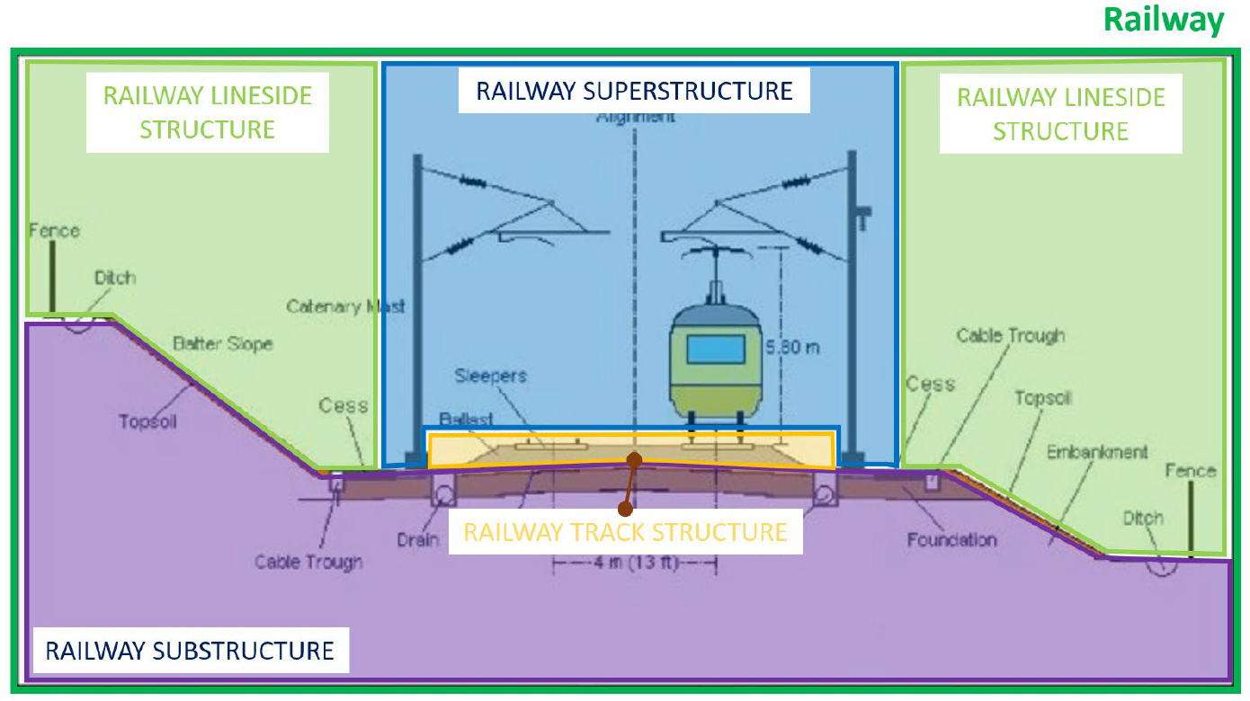

Figure A railway facility structure, source: RWR-IFC_Rail-Requirement_Analysis_Report

For the purpose of creating the model, various information sourced from the Swedish Transport Administration (Trafikverket) will be employed. Additionally, IT solutions developed by Trafikverket or a third-party supplier will be utilized as visualization tools and information holders. The objective is to make the information readily accessible and easily extractable, such as generating reports, directly from the model, which can then be employed in further analysis or monitoring operations.

One category of information that will be utilized in this task is "TRVINFRA" (Trafikverket's infrastructure regulations). These regulations will be linked to different levels or parts of the facility's hierarchy. This type of information will provide a comprehensive understanding of how rules that govern the design and maintenance of various systems and components within a facility can impact other systems or components within the same facility.

#### Approach

Different methods will be used to meet the objectives of the activities of this task. The activities are grouped into 3 phases:

Phase 1: Develop artificial environment (BIM model) for the information of Track superstructure.

Phase 2: Define and digitize the rules for Track structure.

Phase 3: Use the environment as a digital information carrier.

Some of the activities will overlap and be performed simultaneously. The purpose is to be able to identify technical challenges at an early stage and re-evaluate the methods or change working methods if necessary.

**Phase 1: 1 Define model structure (systems and components).**

In this activity, an information model for the artificial environment (BIM model) of a Track superstructure will be established. Unified Modeling Language (UML) will be used to generate and configure the information model. The information model will be structured based on the following concepts:

* Using the standard "IFC-Rail 4x3" model structure developed by the "buildingSMART" group. (~~reference~~)
* Using the information model for "Reference facility" developed by Trafikverket in connection with the feasibility study "Virtual Master facility". (~~reference~~)
* Using the information model for "Reference ID", Trafikverket's common hierarchy and reference designations system for assets in a facility. (~~reference~~)

The purpose of the information model is to identify the different systems and component types that exist in a Track Structure environment. The information model will describe a combination of spatial structure and a physical structure, displaying the relationships between objects and how they are (de)composed using “Aggregation” (i.e. part of, composed of) and “Generalization”. The model will be expressed in structural diagrams based on IFC-Rail 4x3 and IFC 4 (the current official release) schema. (~~Referents detailed description of the working methods~~)

**Phase 1: 2 Define a data structure (types and information structure).**

In this activity, a definition will be established for the different properties that different types of facilitys, systems or components have. The activity is performed in parallel with activity "Phase 1: 1" and will generate data for the UML model. In addition to the geometric properties, properties defined in the feasibility study "Virtual Master Plant" will be used. Information stored in Trafikverket's various IT systems can then (theoretically) be linked to the BIM model in the next phases of the task with the help of a unique "Object Key".

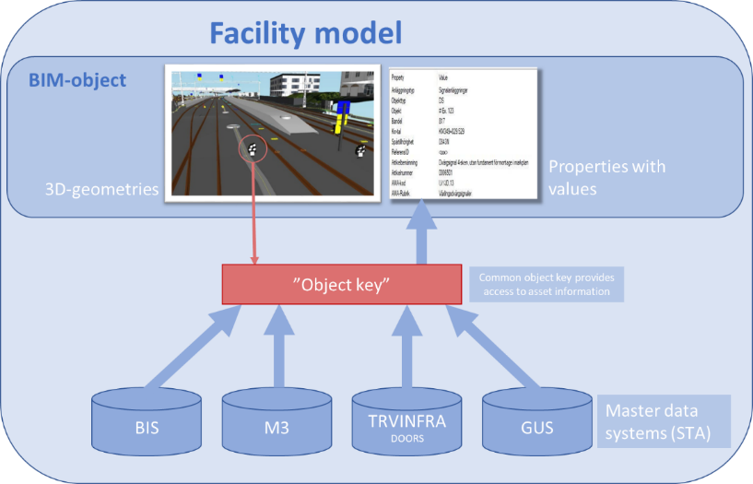

Figure An "object key" enables access to data.

**Phase 1: 3 Identify, collect or create 3D profiles and 3D objects needed to create the BIM model (Object Library).**

Create or collect 3D geometries (BIM objects) for the components defined by the UML model in Phase 1: 1. The BIM objects must be parametric and contain the attributes corresponding properties defined in Phase 1: 2. Different types of CAD / BIM tools will be evaluated to perform this activity.

**Phase 1: 4 Collect input data for the model (sample data).**

In this activity, sample data is collected from the Trafikverket's various databases to use in the BIM model. The goal is that all the properties defined in the UML model will contain data. In the event that the information is missing from Trafikverket's databases, a fictitious but “reality-based” data will be created to ensure that all aspects of the UML model are tested in the BIM model to guarantee a high quality of our proof-of-concept.

**Phase 1: 5 Define appropriate tools for creating the artificial environment (BIM model / database).**

In this activity different types of CAD / BIM tools will be evaluated to define the most suitable tool that can be used to create a BIM model for the entire Track superstructure part of a railway Track. The tools must meet the following criteria to qualify for use as a BIM design tool:

* Has tools for performing parametric design
* Has tools for performing graphical programming to maximize the efficiency of the design process.
* Can export the design to an IFC file format.

Finally, a BIM model of a limited area will be created to use as a basis for the artificial environment (Digital Twin).

**Phase 1: 6 Evaluation of the design concept (gap analyzes)**

A gap analysis will be used to follow up the progress and success of the various above-mentioned activities in Phase 1 and activities in Phases 2 and 3. The analysis will describe the desired result at the end of the project (2023) compared to the start of the project. The analysis will also be used to identify future measures and recommendations for further work.

**Phase 2: 1 define the model's governing regulations.**

During the project, we will use the new regulations for New mainlines "Technical system requirements New mainlines" version 1.0 (TSK_NS_1.0). "Technical system requirements New mainlines" (TSK NS) is a Trafikverket’s document which together with existing regulations (TDOK / TRVINFRA) contains Trafikverket's technical requirements for planning, design, construction, operation and maintenance for the high-speed system on the Stockholm-Gothenburg / Malmö mainlines. TSK NS will be used for ballasted track system for speeds up to and including 250 km / h and ballast-free track system for speeds up to and including 320 km / h. (~~reference~~)

For the purpose of this task, we will only focus on Chapter 8 of the regulations "Track superstructure and track design".

**Phase 2: 2 Develop IT concepts to link the regulations to BIM objects.**

The regulations "TSK NS" will be converted to a digital format and stored in a database that can then later be linked to an object-oriented model. The purpose is to be able to refer via the BIM model to different regulations that govern the design of the systems / objects.

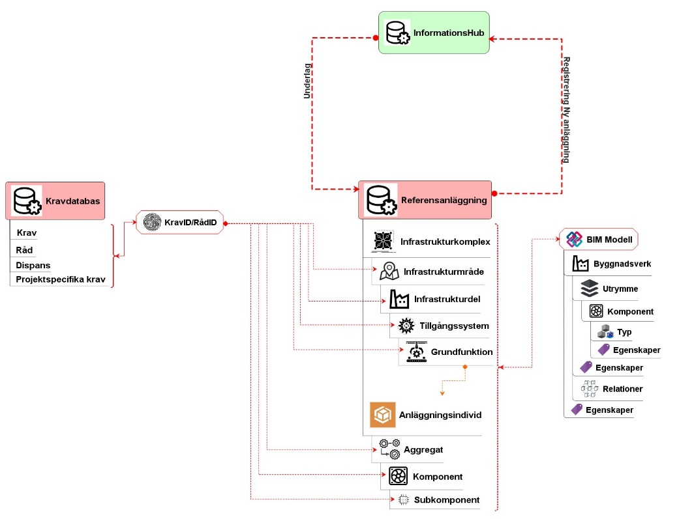

Figure Principle for linking regulations to different objects in the BIM model

**Phase 3: 1 Combine data and 3D objects to create BIM model.**

The last activity in the task is to put all the data together with a corresponding 3D object and create a complete BIM model according to the structure defined in Phase 1. In connection with this activity, different types of "Model Viewer" will also be tested to decide which is best for:

* Visualization of information and 3D
* Export of information in other formats for further analysis with other tools
* User friendliness

#### Results

**1: The information model (system engineering)**

**1.1: definition of the model entities**

The entities of the virtual environment model (the built environment) were organized into different groups based on the ISO standard 12006-2. These entities well make the foundation for any information model needed to describe the built environment:

* Spatial entities
* Structural (Physical) entities
* Property
* Property values
* Property sets

Using Trafikverket own requirement as a starting point, a relational database was created using BIMQ (an information management tool, ~~Appendix_xx~~) to register and manage the different entities with in these groups.

**1.2: Spatial breakdown (spatial entities)**

Based on IFC 4x3 and CoClass, three levels of spatial structures were used to breakdown the built environment using BIM. These levels are categoriz§ed as following:

* Infrastructural complex: an aggregation of several facilities that function together to serve a certain mode of transportation (e.g. Railway or Road)
* Facility: an independent unit in the built environment with a characteristic spatial structure, intended to serve at least one function or user activity that provides a specific function (e.g. Railway Track, Railway bridge or Railway tunnel).
* Facility part: a spatial breakdown of a built facility, a constructive system that aggregates several units (assemblies) and/or several individual components (e.g. Track structure, Superstructure or substructure)

For the probes of this project, the flowing entities were identified and registered in BIMQ:

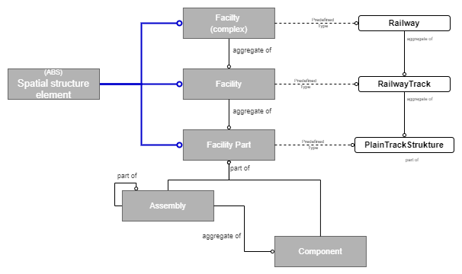

Figure

Trafikverket will be using an additional breakdown system focusing on the functional systems and the intended functions (Basic function) of the built asset, where every basic function is realized by one or many structural (physical) entities. This breakdown was outside the scope of this project and was only considered in some of the tests by adding a placeholder attribute in some structural (physical) entity to convey the basic function of that entity.

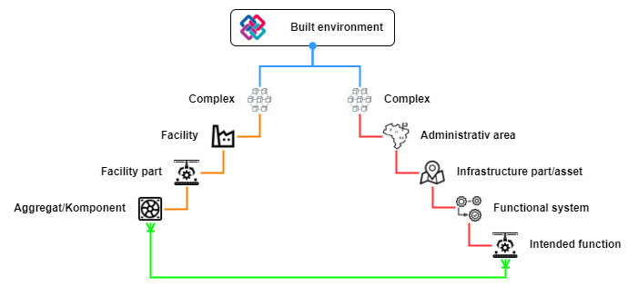

Figure

**1.3: Structural (Physical) entities**

Structural (Physical) entities is a building component/assembly that realizes the design of a construction system (Facility Part). Using Trafikverket predefined list of standard railway components (BVS811) the flowing components were identified as part of the “Plain Track Structure” and registered in BIMQ as well:

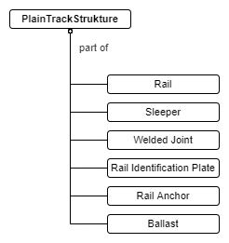

Figure

Trafikverket uses many different configurations of components for the Plain Track Structure but the one described above is the most used in the modern Swedish railway network.

**1.4: Properties, Property sets and Property values**

For every entities descried previously there are many properties connected to them. The properties used to describe these entities in different ways and perspectives. They are the actual information holder and can be used to convey information to both humans and other IT-system. Properties that describes similar type of entities or have a similar use purpose were grouped in a “property sets”. All the properties have predefined data type (~~Appendix~~), and some of the properties have predefined values based on Trafikverket asset management system.

Using Trafikverket asset management system BIS as a starting point, a list of properties were identified for the use porous of asset management. The properties were grouped into property sets (a set for every entity) and registered in BIMQ.

**1.5: entity classification with CoClass**

Using the entities previous type definitions (se 1.2 and 1.3), the entities were classified and organized under CoClass system:

* Facility Complex = Construction Complex (CoClass BX)
* Facility = Construction Entity (CoClass BV)
* Facility Part = Constructive System (CoClass KS)
* Assembly/ Component = Component (CoClass KO)

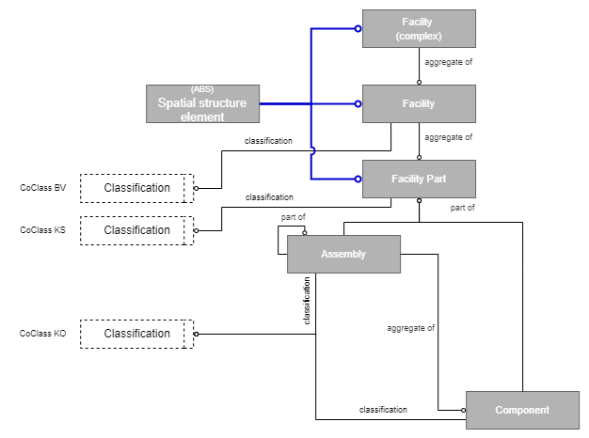

Figure

Every entity Class, subclass and type have its own classification code (registered in BIMQ). The code will be used as an “Object Key” to link information stored in a mockup database (for the governing regulations) to a BIM model as presented in Figure 3.

**1.6: the IFC schema**

The information model was used to construct a BIM model using the IFC file format. The current official version of IFC (IFC 4) does not support a railway facility and used primarily for building related structures and systems. However BuildingSmart (the group responsible for the authoring of the IFC standards) is in the late stages of a development process for a new rail/road IFC standard (IFC 4x3). After a dialog with BuildingSmart a decision was made to develop the information model in both IFC 4 and IFC 4x3, using “user defined” entities and properties to complete IFC 4 with railway related entities and properties. Spatial entities like “Building” and “Building Storey” were used instead of “Railway” and “Railway Part” (se the example in figure 8).

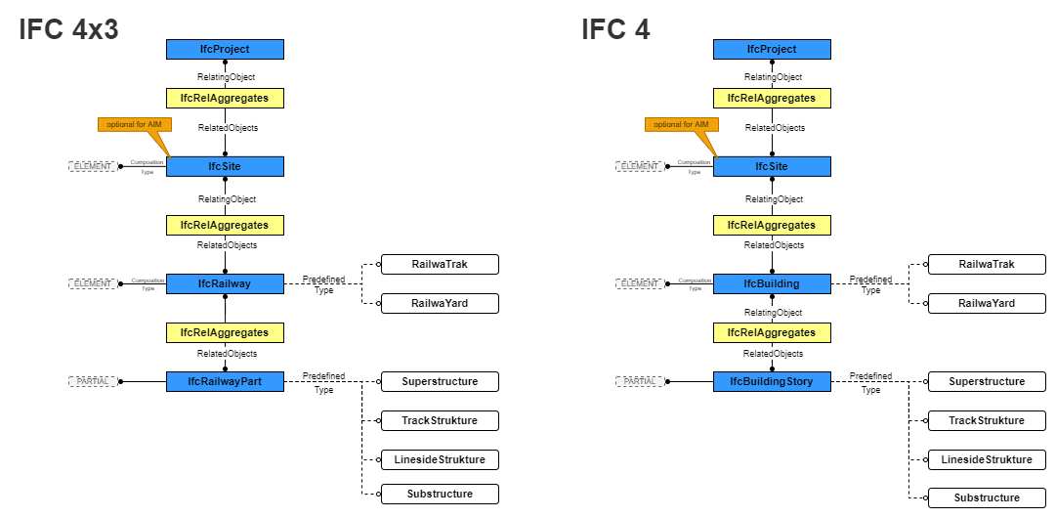

Figure

**2: The design process**

The proposal for this project was to create a model for a railway track structure. This system contains both continuous (linear) structures (i.e. rails and ballast) and discontinuous (nonlinear) object (i.e. sleepers, joints and fasteners/anchors). Automated computational design was chosen as the main principle for the design- and model production process. The tools used in this project were:

* Autodesk Civil 3d: modeling for designing the track geometry and the 3D linear objects.
* Autodesk Revit: modeling tool for designing the nonlinear objects and object information management.
* Dynamo: programming environment for computational BIM design that enables the user to use visual logic to design workflows and automate tasks.

Using method described in earlier works (~~reference~~) and combined with Autodesk educational materials (~~Reference CES322249~~) the flowing process was created:

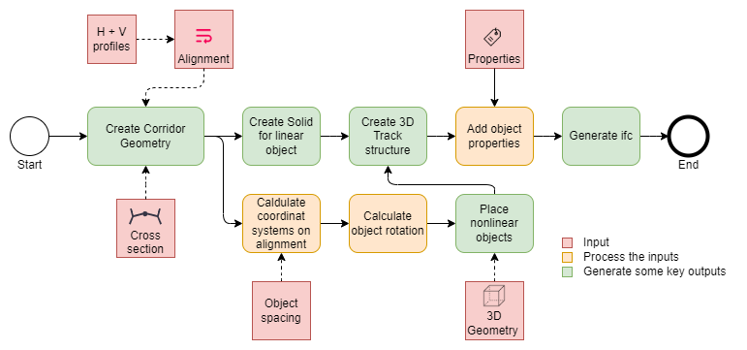

Figure

#### Maturity, remaining research and suggestions for implementation

**Technology readiness level (TRL)**

Most of the concepts used in this project are experimental and none are fully developed or deployed before. At this point we are moving from level three (experimental proof of concept) to level four (Technology validation in lab). The information model developed in the initial phase of this project and the design process are being tested and validates for multiple configurations of objects (entities) in the built environment of the track structure.

The aim is to have demonstration of these technologies in a relevant environment (level six) at the end of the project. That is a working virtual environment that contain 3D representation of the track structure and provides an access to information about the governing regulation as presented in figure 3.

**Remaining research**

Phase 2: Develop IT a concepts to link regulations to the BIM objects:

* Using methods similar to the once used in defining the Building Information Model to define an information model for the regulations and roles governing components in the BIM-model.
* Leveraging Semantic Modelling and Data Linking.

Phase 3: Combine data and 3D objects to create BIM model:

* Putting all the data together with a corresponding 3D object and create a complete BIM model according to the structure defined in Phase 1. In connection with this activity, different types of "Model Viewer" will be tested.

#### Appendices

Xxx

#### References

Xxx

### Evolution and degradation of ground rail in digital twin

Simulate evolution and degradation of ground rail under operational traffic in a digital twin fashion (CTH for TRV).

#### Responsible partner: Chalmers for Trafikverket (Fredrik Larsson)

#### In cooperation with Caroline Ansin, Ragnar Larsson and Magnus Ekh (all at Chalmers).Background and objectives

A digital twin for the modelling of rail deterioration under traffic will be developed and exploited. The digital twin aims at combining accurate predictions with fast (i e, much faster than real time) and memory-efficient computations and will be continuously updated by the aid of field measurements.

The need for digital twins relates to the requirement on predicting deterioration and failures – in relation to both operations/maintenance and to design of new products. Improved predictive abilities support the main challenges of the railway: improved punctuality (through enhanced robustness by identifying and mitigating problems before they occur), increased capacity (through better opportunities to predict and target maintenance), reduced cost (through improved abilities to tailor solutions, and through decreased needs for physical testing), and improved sustainability (through decreased use of material and energy).

The approach and the required material models adopted in the current project build on the work on modeling tools developed in In2Track-2 with application to switches and crossings. In an integrated simulation framework, these tools allow for simulation of evolving geometries due to plastic deformation and wear, accounting for detailed analysis of the vehicle-rail interaction.

Specific goals:

1. Establish a digital twin of a rail section in a curve. The numerical model will consist of a two-dimensional representative cross-section, where geometry changes due plasticity and wear from traffic load can be simulated.

2. Develop a reduced order model in order to allow for fast and memory efficient simulations during a high number of load cycles.

3. Incorporate model updating based on geometry measurements (e.g. Mini-prof measurements).

4. Apply simulation tools to predict (forecast) geometry changes (plasticity and wear) and crack formation under current and/or updated operational conditions.

#### Another important aim of the project is that the developed tools should be possible to use for cost–benefit evaluation of grinding geometries and intervals for a specific loading condition.Approach

The digital twin in this project will predict how the cross-sections of rail evolve with time after grinding due to plasticity and wear as well as when cracks initiate and, finally, when need for re-grinding occurs. The simulation results will be compared against experimental data from field such as profile measurements (e.g. Mini-prof measurements) and possibly additional measurements. Besides verification, the experimental data will be used in a digital twin framework to update and improve the simulation tool continuously.

The first study will be based on the modeling tool developed in In2Track2 for prediction of the deterioration of switch rail due to plastic deformation and wear. The modeling tool consists of the following building blocks:

• Dynamic vehicle-track simulations to extract contact loads,

• an idealized FE-based meta-model for estimating contact stresses on the rail accounting for inelasticity,

• a two-dimensional finite element model of a rail cross-section for simulation of plastic deformation, and

• a model for predicting wear at the contact position.

The blocks are fully coupled in the sense that the predicted geometry change of the rail profile can be accounted for in contact model of the dynamic vehicle-track simulation. The geometry of the rail profile is parametrized in the numerical model. For estimated traffic load, the predicted profile changes will be compared to measurement in field, allowing for model calibration. In addition to the mentioned components, crack initiation and formation will be studied based on extracted contact stresses. At a later stage, the criterion may be exchanged for a model with higher fidelity based on e.g., the predicted inelastic strains in the finite element model.

#### In order to allow for tracking the geometry changes following grinding, the continuation of the project will focus on developing (i) fast simulation tools, so-called reduced order modeling, to allow for better resolution of the rail surface geometry, and (ii) develop a framework for model calibration and geometry updates from field measurements.Results

Xxx

#### Maturity, remaining research and suggestions for implementation

Xxxx

#### Appendices

4.1.2a Jessop, Casey, and Johan Ahlström. 2019. “Friction between pearlitic steel surfaces.” *Wear* 432–433: 9 pp.

#### References

References must be according to Chicago style using author–date referencing style. The style of referencing is extensively detailed in https://libguides.williams.edu/citing/chicago-author-date and https://www.chicagomanualofstyle.org/tools_citationguide/citation-guide-2.html

#### Data to be managed

Description of data to be managed:

Responsible for storage:

Availability and restrictions:

### Whole system modelling and hybrid testing methodology

Enhance and validate the the advances on simulation models following the whole system approach, using the outcomes and knowledge from the IN2TRACK project family. Investigate and define the application, development of hybrid testing methodology, where simulation tools, laboratory and field tests provide a whole system assessment, aim at TRL7, supported by VARS (VIF).

#### Responsible partner: ViF (Gerald Trummer)

Xxx

#### Background and objectives

The whole system modelling was already developed in the two previous projects (In2Track and In2Track2). The basic structure was developed in In2Track and the whole system modelling was expanded and validated with the planned demonstrator in In2Track2. This result will be used in the In2Track3 project as a starting point to improve the whole system modelling.

#### Approach

* Parameterisation and validation of the models as well as on the implementation in the overall system modelling approach.
* Implementation of the White Etching Layer (WEL) results into the overall system modelling approach
* Parameterisation and validation of the models for the prediction of the development of the verical track geometry with field data

#### Results

Xxx

#### Maturity, remaining research and suggestions for implementation

Xxxx

#### Appendices

4.1.3a Jessop, Casey, and Johan Ahlström. 2019. “Friction between pearlitic steel surfaces.” *Wear* 432–433: 9 pp.

#### References

References must be according to Chicago style using author–date referencing style. The style of referencing is extensively detailed in https://libguides.williams.edu/citing/chicago-author-date and https://www.chicagomanualofstyle.org/tools_citationguide/citation-guide-2.html

#### Data to be managed

Description of data to be managed:

Responsible for storage:

Availability and restrictions:

## Track and component monitoring ST 3.4.2 (TUD for PROR, CTH and LTU for TRV, UoB for NR, RAILEN, SNCF-R, M1-M33)

**Responsible:** PROR (Person)

In collaboration with IN2SMART-2

### Track status assessment

Build on the work in In2Track2 to improve the ability to specify demands on health related track and rolling stock monitoring systems and to employ data for status assessment and prediction of health evolution. Outline how employed data can be connected to maintenance decisions and how simulations can be employed to estimate the effectiveness of such actions (CTH for TRV).

#### Responsible partner: Chalmers for Trafikverket (Anders Ekberg)

In cooperation with Elena Kabo.

#### Background and objectives

The research set of in In2Track2 (Ekberg and Kabo 2021) with an overview of how track status can be assessed. This included an overview of different deterioration phenomena, influencing parameters, and how these relate to available models to predict deterioration rates. One main aim of that initial work was to divide the challenge of track health predictions into manageable pieces where mechanisms, consequences, needs and possibilities can be discussed. In addition, the report provided an indication of available monitoring and predictive abilities.

The main aim of the current study is to expand the work in In2Track. This will be done by being more specific on possible prediction strategies for a selected use case where possibilities and challenges for future track health prediction approaches can be outlined and contrasted with current operational practices.

#### Approach

The research will expand on the literature study in In2Track2. To that overview calculations will be made to provide rough quantifications of effects. In addition, operational practices for the use case will be compiled in cooperation with an infrastructure manager.

#### Results

Xxx

#### Maturity, remaining research and suggestions for implementation

Xxx

#### Appendices

4.2.1a Jessop, Casey, and Johan Ahlström. 2019. “Friction between pearlitic steel surfaces.” *Wear* 432–433: 9 pp.

#### References

Ekberg, Anders, and Elena Kabo. 2021. ”Key parameters and requirements for track health prediction.”, Chalmers University of Technology.

#### Data to be managed

Description of data to be managed:

Responsible for storage:

Availability and restrictions:

### Assessment of RCF detection data

Exemplify the work in section 4.2.1 by proposing a process on how to utilise the information from detecting RCF (the outcome of the activity in section 4.2.3) for enhancing maintenance decision related to e.g. rail grinding. (LTU for TRV)

#### Responsible partner: PARTNER (Matti Rantatalo, Matthias Asplund)

Xxx

#### Background and objectives

This study is connected to the activity described in section 4.2.3 (System prototype demonstration of RCF detection) where measurements of wagon axel box acceleration is used to evaluate the presence of squats on the rail. This study will generate similar measurements but from a locomotive. The main advantage by using a locomotive installation is the access to electrical power and a sheltered environment and for measurement equipment as well as a constant weight of the train, which many cargo wagons lack depending on its cargo. One of the issues with locomotive installations is however the presence of traction and motor/drive line induced vibrations. The constant load will however grant the possibility of combining multiple measurements of the same section.

The main objective of this study is to examine the possibility of using locomotive installations for squat detection or other track related properties which could affect the dynamics.

#### Approach

The study is based on a practical measurement approach and a theoretical data analysis approach. The practical measurement approach includes the gathering of axel box vibrations from an in service locomotive. The data analytics approach includes signal processing and comparisons of results generated by the activity in 4.2.3. The main tasks within this activity is to define a test section along a railway track. This track should be used for both this study and for the study described in section 4.2.3. The approach will include an iterative process where measurements will be followed by data analysis and track visits for validation purposes.

#### Results

Xxx

#### Maturity, remaining research and suggestions for implementation

Xxxx

#### Appendices

4.2.1a Jessop, Casey, and Johan Ahlström. 2019. “Friction between pearlitic steel surfaces.” *Wear* 432–433: 9 pp.

#### References

References must be according to Chicago style using author–date referencing style. The style of referencing is extensively detailed in https://libguides.williams.edu/citing/chicago-author-date and https://www.chicagomanualofstyle.org/tools_citationguide/citation-guide-2.html

#### Data to be managed

Description of data to be managed:

Responsible for storage:

Availability and restrictions:

### System prototype demonstration of RCF detection

Perform system prototype demonstration in operational environmental for detection of Rolling Contact Fatigue (RCF), especially squats, by sensors e.g. axle box accelerometers. Perform field demonstration (e.g. Sweden) in collaboration with TRV, TRL7 (PROR). Support PROR’s demonstration of RCF detection system (TRV/CTH/ LTU).

#### Responsible partner: PARTNER (Persons)

#### Alfredo Núñez (TUDelft for PROR), Zili Li (TUDelft for PROR), Rolf Dollevoet (TUDelft for PROR), Jan Moraal (TUDelft for PROR), Jurjen Hendriks (TUDelft for PROR) + team of colleagues from TUDelft for PROR.

#### Arjen Zoeteman (PROR) + team of colleagues from PROR.

#### Matthias Asplund (TRV) supporting the demonstration in Sweden + in cooperation with Linked Third Parties (CTH / LTU).

#### Background and objectives

#### The ABA measurement system developed by TUDelft has been used to detect RCF. The technology is to be tested for the TRL7 level. The system measures longitudinal and vertical ABA to detect short wave irregularities such as squats. While in this task a particular focus is the analysis of squats, the system is also capable of detecting other types of railway track irregularities, RCF, and of supporting the assessment of the condition of joints, insulated joints, switches and crossings, welds, transition zones, bridges and other railway assets.

 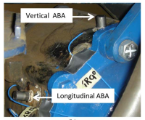

#### Figure: ABA measurement system (Source: Molodova et al., 2014, Li et al., 2015)

#### We are aiming for a field demonstration campaign for the detection of RCF using ABA. Our primary target is to collaborate with TRV to perform the field demonstration in Sweden in the Iron Ore Line operated by LKAB between Lulea and Narvik. One significant challenge is finding the rolling stock that we can use to mount the sensors and perform the measurements. Therefore, we will evaluate all the available possibilities and perform a tradeoff analysis to guarantee a successful campaign. The options are from evaluating available wagons from LKAB, other measurement trains from Sweden, and including the transporting from The Netherlands to Sweden of the measurement train of the TUDelft.



#### Figure: Iron Ore Line (Source: https://en.wikipedia.org/wiki/Iron_Ore_Line)

#### Part of the objectives in this task is to organize visits and arrangements for measuring the target tracks. That includes track inspection, measurements, and analysis of available railway track condition data. The preparation work requires the team of TUDelft and PROR to travel to Sweden, so to conduct preparations and measurements. Analysis and processing of currently available data can be conducted upon the availability of such data. After the ABA measurement campaign is planned, we expect to conduct multiple runs of measurements, various days, various kilometers of track. The final deliverable will include analysis and validation of the most important findings. Some of the challenges include processing massive amounts of data in a short period over various hundreds of kilometers of track data. In addition, the latest development of Big Data and processing capabilities will be tested to evaluate the capabilities of the detection method. The track site is of particular interest because we aim to test the technology under different track conditions. So far, we have tested ABA measurements in conventional lines, high-speed tracks, tramways, and regional railways. The testing in a freight-dominated track will provide extra insights into how defects behave in this type of track. Together with the measurement system, this understanding will provide meaningful information for tailoring grinding and replacement operations.

As a final remark, in the grant agreement, we indicate that the field demonstration to be considered will be “e.g., Sweden.” This allows for defining a backup plan to perform the demonstration campaign in another railway line or another freight-dominated route, or another railway line in another country. This last resort is to be considered if difficulties due to travel restrictions make it difficult to conduct the necessary experiments and preparations for the demonstration campaign in Sweden.

#### Approach

We collect data from accelerometers, a GPS receiver, and either a tacho signal or a speed sensor. A number of accelerometers are mounted on the axle boxes (preferable at least on one bogie). Small mounting studs have to be glued to each axle box. These are small spots of about 2x2 cm that are needed to be free of paint and grease. After the measurement, these mounting studs are not removed. Although the size of the required spots is small, this is still to be known in advance by all parties involved in the measurement campaign. Cables are needed from the sensors to the data acquisition in the train. These cables can be attached by ties that can be removed.

Installation of the system can take two full days. It is strongly recommended to have a dry area, preferably indoor, available for this (for instance, having the train in a workshop). This is because the axle boxes need to be dry when performing the gluing. The mounting of the GPS antenna might require additional efforts, strong magnets can be used to hold it, but additional measures can be required to keep the antenna in a safe position. Finally, the measurement box with the data acquisition system requires a 230V /50Hz power supply.

#### Results

Xxx

#### Maturity, remaining research and suggestions for implementation

Xxxx

#### Appendices

xxxx

#### References

Molodova, Maria, Zili Li, Alfredo Núñez, and Rolf Dollevoet. 2014. “Automatic detection of squats in the railway infrastructures.” IEEE Transactions on Intelligent Transportation Systems 15(5):1980-1990.

Li, Zili, Maria Molodova, Alfredo Núñez, and Rolf Dollevoet. 2015. “Improvements in axle box acceleration measurements for the detection of light squats in railway infrastructure.” IEEE Transactions on Industrial Electronics 62(7):4385-4397.

#### Data to be managed

Description of data to be managed:

Responsible for storage:

Availability and restrictions:

### Friction level sensor

Develop rail eye (optical sensor system) for defining and categorising the friction level on the rail surface in field environment, TRL7 (LTU for TRV)

#### Responsible partner: PARTNER (Persons)

LTU (Johan Casselgren)

#### Background and objectives

During 2016-2018, Luleå university of technology together with the Swedish Transport Administration evaluated the optical sensor Rail eye. Where it was concluded that it is possible with the Rail eye, in a controlled environment, to distinguish Electro Gel and Head Lub 90 from dry and wet rails. What is interesting here is of course how the friction changes depending on the different materials on the rail. Because it is the friction that is relevant in this context. What was especially interesting was that even though the human eye could not detect the lubricant, the Rail eye detected a thin film that remain on the rail and in that way reduced the friction. The rail eye is first and foremost designed to detect leaf mass on the rail. The sensor consists of two lasers with the light wavelength 1310 nm and 1550 nm and two photodetectors that measures the reflected light from the two light sources.

Physically, the sensor works as intended, the problem is that the sensor measures on an area of ​​about 1 cm, not covering the completely rail width. If a sensor were mounted on a locomotive or a measuring train, there could be a problem with measuring the contact surface, which is the surface of interest as this is where the contact between rail and wheel takes place. The problem with detection would arise when the sensor measures both on the contact area that is smooth and the "rusty" unused surface. For some time now, cameras or line detectors have been launched on the market with the same sensitivity as the photodetectors in the Rail eye sensor. These cameras would allow monitoring of the entire width of the rail, which would provide a better overview of the contact surface and detection. An example of such a camera is the SPECIM FX17, but the disadvantage with the camera is the cost, it is more expensive than the Rail eye system.

The purpose of this project is to mount the Rail eye sensor on a train or a measuring wagon to investigate how the measurement is affected by the motions of the train or wagon in relation to the rail, to verify or reject the hypothesis that the measuring spot is too small. Parallel with this work a demonstrator of a camera system will be constructed. The construction of the demo system will mainly focus on the illumination part of the system to make the system independent of surrounding light as the sun. As the project is limited in time the test with the Rail eye system will focus on fall and winter conditions, to find leaves, top of rail lubrication, ice and water contaminations on the rail.

#### Approach

The approach of the project is to mount the Rail eye sensor on a train or a measuring wagon to test it in an operational environment. This will also give information if this type of optical sensors can manage the harsh environment and through that reach TRL level 7.

Within this project there is also an approach to design a prototype for the detection of various contaminants on the rails across the hole cross section of the rail. With the purpose of investigate the possibility of controlling top of rail lubrication for mounting on trains. The prototype must be designed with lighting that is modulated so that the measurements are independent of ambient light and a line-detector that can measure the entire cross section of rail. This prototype must then be evaluated in a controlled environment and then mounted on, for example, an equipment that is pushed on the rail to test it in a relevant environment.

#### Results

#### Maturity, remaining research and suggestions for implementation

There is no connection to previous project IN2TRACK II. The Rail eye sensor is today at TRL level 6 and within this project the sensor will be upgraded to TRL 7. Then there are already systems that could be used for logging and positioning to start test implementation of the sensor for real rail monitoring.

The maturity of the rail camera system is much lower but within this project a demo prototype will be tested.

#### Appendices

#### References

#### Data to be managed

Description of data to be managed:

Responsible for storage:

Availability and restrictions:

### Train-borne tribometer

Develop a train-borne tribometer for friction/adhesion management, enhancing the knowledge of the friction in field and its impact on the wheel rail system in terms of RCF and adhesion, perform test in lab and summarize the tests, TRL4 (PROR)

#### Responsible partner: PARTNER (Persons)

#### ProRail (Zhen Yang)Background and objectives

Friction/adhesion management in railway networks is a challenge for infrastructure managers and railway operators. Friction/adhesion at the wheel-rail interface influences the braking and traction performance of railway vehicles and the formation of wheel and rail defects. A minimum level of friction/adhesion must be guaranteed to ensure appropriate braking and traction of vehicles, whereas high friction/adhesion increases wear and rolling contact fatigue of wheels and rails, noise emissions and carbon footprint (transportation energy consumption).

#### A crucial part of friction/adhesion management is to reliably measure the wheel-rail friction levels and creepage. A train-borne tribometer is desired because the wheel-rail friction level depends on, among others, the normal contact load and speed. A light vehicle will thus experience adhesion differently than a heavy train, and the accuracy of hand-pushed tribometers is adversely affected by scaling and low speed. This project aims to develop a train-borne tribometer for friction/adhesion management. Approach

To achieve the TRL4, a comprehensive lab test will be conducted in the V-Track test roller rig in the Railway lab of TU Delft. A detailed description of the structure and components of V-Track can be found in the figure below. The COF will be measured with two schemes: 1. increase AoA to get friction saturation in the lateral direction and 2. Increase traction/braking torque to get friction saturation in the longitudinal direction. The wheel-rail contact forces in the three directions, AoA, wheel rolling and rotational/circumferential speed, and traction/braking torques will thus be measured and analysed to obtain the COF of the V-Track. The vertical load can be controlled in the amplitude between 0 and 7500 N by two preload springs. A braking motor is connected to the wheels to apply appropriate traction/braking/ forces. The AoA is adjustable between -2° and +2°. The wheel rolling speed range is between 0 and 40 km/h. A force measurement system called dynamometer has been developed in the V-Track to measure the wheel-rail contact forces.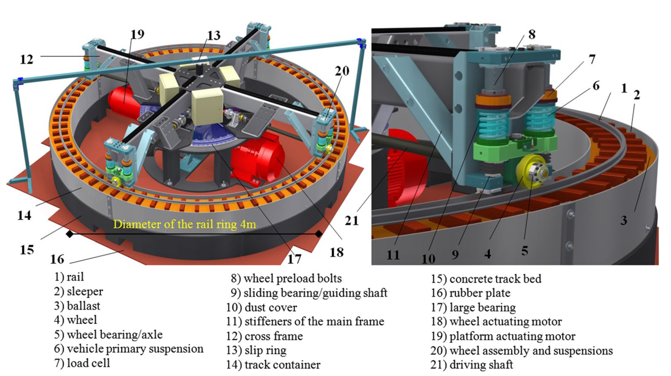

Figure: structure and components of V-Track test roller rig (Naeimi et al, 2017)

#### Results

The figure below shows the adhesion coefficients (ACs) measured along one V-Track circle in the project In2Track2. The AC increases with the AoA, and when the AoA is sufficiently large, significant stick-slip contact occurred, which indicates saturation of friction force, and the measured maximum AC is the COF. In this In2Track3, the COF will be measured by increasing the traction/braking torque applied to the wheel axle and achieving friction saturation in the longitudinal direction. The COFs measured by the two approaches will be cross-validated; otherwise, the difference will be analyzed and improvement/calibration of the measurement system will be made.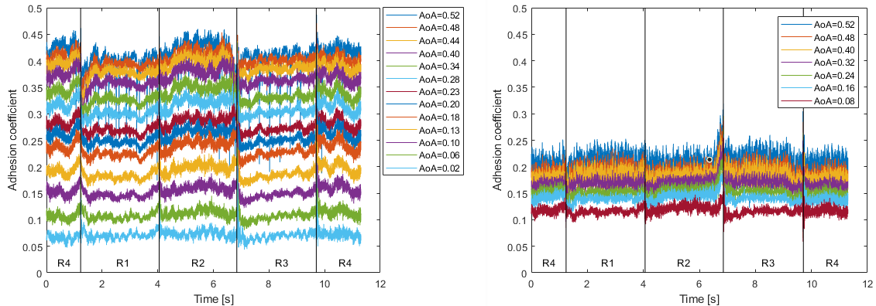

Figure: The measured ACs over the V-Track circle

#### Maturity, remaining research and suggestions for implementation

Xxxx

#### Appendices

#### References

Naeimi, M., Li, Z., Petrov, R. H., Sietsma, J., & Dollevoet, R. (2017). Development of a New Downscale Setup for Wheel-Rail Contact Experiments under Impact Loading Conditions. Experimental Techniques, 42(1), 1-17. doi:10.1007/s40799-017-0216-z

#### Data to be managed

Description of data to be managed:

Responsible for storage:

Availability and restrictions:

### Data mining to identify performance critical parameters

Continue to develop the approach from IN2TRACK2 to look at existent data sets to find new parameters that can be used to improve the performance (reliability, availability and safety) of the railway system by building upon the work done in I2T2 that used artificial neural network, machine learning etc., including soft demonstrations, TRL5/6 (UoB for NR)

#### Responsible partner: PARTNER (Persons)

Ian Dean Network Rail

#### Background and objectives

During IN2TRACK2, Network Rail worked with the University of Birmingham to undertake a literature review of machine learning and data analysis with data streams available in the rail industry. This was used to formulate the groundings of an approach for fusion of data streams to decipher patterns for the purpose of developing prediction of the track condition.

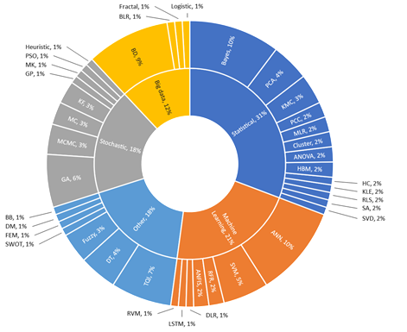

The work concluded with identifying 10 data streams applicable for examination but 3 were not practical for pursuit as they involve the installation of none standard lineside sensors which reduces the cost benefit ratio significantly.

|  |  |  |  |  |
| --- | --- | --- | --- | --- |
| # | Category | Factor | Potential Data Sources | Potential Algorithms |
| 1 | Track Design | Differential settlement | Track Geometry, Design information, LiDAR | ANN, Logistic regression, Bayesian models |
| 2 |  | Stiffness | Track Geometry, GPR, FWD, Geophones, DIC | No specific algorithms used |
| 3 |  | Transitions | Design Information, Geophones, DIC | GA |
| 4 | Loading | Dynamic Load | WILD, Strain gauges | FEM |
| 5 |  | Gross Tonnage | Traffic data | ANN, Supervised Learning, Ensemble Learning |
| 6 |  | Speed | Traffic data, IMU, Tachometer | Linear regression, Fuzzy inference models |
| 7 |  | Vehicle Type | Traffic data | No specific algorithms used |
| 8 | Environment | Temperature | Weather Forecast, Thermometer | Monte Carlo simulation, Bayesian models |
| 9 | Weather Events | Weather Forecast, Incidence Reports | ANN, Bayesian models |
| 10 | Maintenance | Tamping operations | Maintenance Records | Bayesian models, text mining, parametric distributions |

Of the remaining 7 data streams, elements of track geometry were investigated with weather data using regression analysis to determine the basis and scalability of establishing patterns within the data sets of two routes that had different comparable soil types. A linear relationship was established with appropriate R2 values lending confidence that 200m sections were the optimized size of examination and the scalability of the analysis could be undertaken using a standard office computer readily available to infrastructure engineers.

This work laid the foundations to continue further fusion & machine learning techniques on the remaining data streams with an established approach concerning the tradeoffs necessary to generate an output within the capability of a commercially available computer.

#### Approach

The approach will be a continuation of exploring differing machine learning techniques in an iterative fashion with additional increase in data streams and establishment of the optimum capability with developed algorithms and associated confidence levels for the prediction of the track condition concerning the standard deviation of longitudinal level.

#### Results

Xxx

#### Maturity, remaining research and suggestions for implementation

Xxxx

#### Appendices

#### References

References must be according to Chicago style using author–date referencing style. The style of referencing is extensively detailed in https://libguides.williams.edu/citing/chicago-author-date and https://www.chicagomanualofstyle.org/tools_citationguide/citation-guide-2.html

#### Data to be managed

Description of data to be managed:

Responsible for storage:

Availability and restrictions:

### Influence of track stiffness variations

Continue the work in IN2TRACK2 to study the variation of track stiffness and related monitoring systems to deliver improvements in track geometry resilience, to TRL6 (NR).

#### Responsible partner: NR (Wei Khang Lim)

#### Background and objectives

Discontinuities in the track system such as transitions between ballasted track and structures (i.e. bridges) or presence of soft spots in the subgrade can lead to variation in track stiffness. If these variations are too abrupt, it can lead to rapid and severe deterioration of track geometry and increased occurrence of track faults. Whilst this correlation between track stiffness and track geometry degradation is well known within the rail industry, most railways in Europe have not implemented any standardised process in managing and maintaining the track stiffness of a built track. This can partly be attributed to the lack of a cost effective method for large scale monitoring of track stiffness, as well as the limited understanding of the relationship between track stiffness and track geometry.

To tackle these challenges, the research conducted in In2Track2 built upon a relatively low cost prototype track stiffness measurement system previously developed by NR which utilises axle box accelerometers fitted to two differently loaded axles on one of NR’s measurement vehicle to derive rate of change of track stiffness over distance (ΔΤS) – see Figure 1 below.

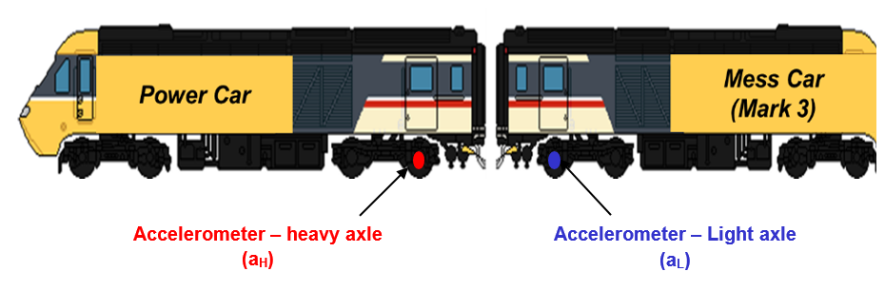

Figure 1: Network Rail prototype track stiffness measurement system

One of the objectives in In2Track2 was to further validate and optimise this prototype measurement system by comparing its ΔΤS output against field data obtained from an established track stiffness measurement technique using Digital Image Correlation (DIC) cameras which derives ΔΤS from measured rail deflection. However, due to various hardware faults and COVID-19 restrictions, only 2 site measurements were conducted in In2Track2 instead of the 5 originally planned. Therefore, this study aims to utilise the lesson learnt from In2Track2 to improve the hardware reliability and data management aspect of the prototype system and continue the work on validating and optimising the system through more site measurements and further sensitivity analysis.

Besides that, through the use of a vehicle-track Finite Element model, the research in In2Track2 simulated the effects of track stiffness variation on ballast/subgrade degradation and established a set of theoretical thresholds for ΔΤS, above which the degradation of ballast and subgrade would be deemed unacceptable, resulting in rapid deterioration of track geometry. These thresholds will have to be further validated against field data in this study through long term monitoring of known problem sites and new unknown sites identified by the prototype system.

Finally, to realise the goal of improving track geometry resilience, further research has to be carried out to understand the effect of track maintenance interventions (e.g. tamping, stoneblowing, ballast cleaning etc.) on ΔΤS. Besides that, assessment of existing and novel techniques/products used for managing and mitigating against differential settlement around transition zones should also be carried out to quantify the benefit they bring to track geometry resilience and overall track longevity. This would help build the knowledge of appropriate interventions for track sections with poor ΔΤS.

To summarise, the objectives for this study in In2Track3 are:

* Further validate and optimise the prototype track stiffness measurement system to demonstrate confidence in its output
* Validate and optimise the theoretical thresholds for ΔΤS developed in In2Track2
* Assess effectiveness of track maintenance methods in relation to track stiffness variation

#### Approach

This study will consist of the following key activities:

* Implement improvements to the prototype track stiffness measurement system used in In2Track2 based on the lessons learnt to improve reliability and data management of the system
* Increase confidence in the ΔΤS output from the prototype system by:
  + Carry out sensitivity analysis to test the dependency of the ΔΤS derivation algorithm on key parameters such as track roughness, track curvature and vehicle speed
  + Verify repeatability and reproducibility of output under different operating conditions (e.g. vehicle speed, track curvature, track roughness etc.)
  + Further validate the prototype measurement system through site measurements using track deflection camera
* Refine and validate the ΔΤS thresholds developed in In2Track2:
  + Carry out additional modelling to investigate scenarios of track stiffness variation on existing structural transitions (such as bridges, slab track etc.) with different track bed transition designs and subgrade conditions.
  + Validate the ΔΤS thresholds by comparing the track geometry degradation rate at known problem sites against the measured ΔΤS output from the prototype system. Additionally, new unknown sites with potential ΔΤS issues identified by the prototype system should also be monitored to further validate the capability of the system and thresholds.
* Analyse of effects of various relevant maintenance interventions on ΔΤS by comparing the ΔΤS output from the prototype system before and after the intervention.

#### Results

Xxx

#### Maturity, remaining research and suggestions for implementation

Xxxx

#### Appendices

4.2.5a Jessop, Casey, and Johan Ahlström. 2019. “Friction between pearlitic steel surfaces.” *Wear* 432–433: 9 pp.

#### References

References must be according to Chicago style using author–date referencing style. The style of referencing is extensively detailed in https://libguides.williams.edu/citing/chicago-author-date and https://www.chicagomanualofstyle.org/tools_citationguide/citation-guide-2.html

#### Data to be managed

Description of data to be managed:

Responsible for storage:

Availability and restrictions:

### Embedded sensors for prognostics and health management

Demonstrate the developed embedded sensors (from IN2TRACK2) in the track system for improved Prognostic and Health Management (PHM) with the intelligent sensor network that enhances the maintenance decisions of track maintenance. This sensor will be able to measure temperature, vibration and noise. Integrated AI will allow for process the data and predict failures. TRL6 (RAILEN).

#### Responsible partner: RAILEN (Samir Assaf, Asma Ladj)

#### Background and objectives

During IN2TRACK2 connected sensors have been developed to monitor track system. These sensors adapted to be used in railway environment can collect and transmit data using IoT technology. These data are then processed and visualized to help monitoring track. The targeted data are Temperature (thermal resistance), Acceleration (accelerometer), Noise (microphone) and Geolocation (GPS). Several networks are used to ensure that data is properly transmitted due to the disturbance that exist in railway and the influence of weather conditions. Figures below show the main features of these sensors.

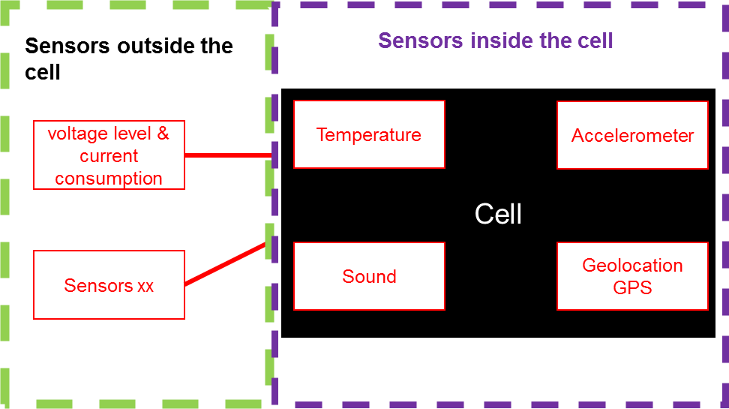

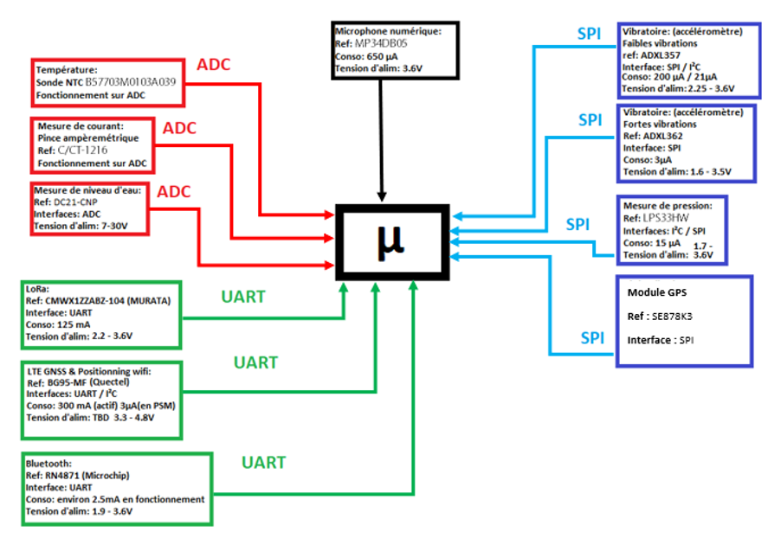

The objective of the work is to finalise the functional tests and validation of these connected sensors along with the telecommunication and associated algorithm for data transmission at lab scale and then to demonstrate their performance in real conditions.

#### Approach

* Functional tests and validation at lab scale
* On-site installation in collaboration with IP
* Test and validate the performance of the connected sensors

#### Results

Xxx

#### Maturity, remaining research and suggestions for implementation

Xxxx

#### Appendices

4.2.6a Jessop, Casey, and Johan Ahlström. 2019. “Friction between pearlitic steel surfaces.” *Wear* 432–433: 9 pp.

#### References

References must be according to Chicago style using author–date referencing style. The style of referencing is extensively detailed in https://libguides.williams.edu/citing/chicago-author-date and https://www.chicagomanualofstyle.org/tools_citationguide/citation-guide-2.html

#### Data to be managed

Description of data to be managed:

Responsible for storage:

Availability and restrictions:

### Assessment of renovation critical areas

Apply on an operational case a diagnostic method for assessment of critical areas before renovation of track, based on correlation between track geometry data, maintenance data and environmental parameters, TRL 7 (SNCF-R).

#### Responsible partner: SNCF RESEAU (Hugues BILLETTE DE VILLEMEUR / Amine DHEMAIED)

#### Background and objectives

#### Ballast and track regeneration processe s for SNCF RESEAU’ ballasted tracks are initiated by track regeneration master plans, followed by track investigations, track studies and finally ballast/track regeneration works. One of the drawbacks of these processes is the absence of a thorough track system analysis.

#### In some cases, ballast and track generation appears to be insufficient to recover track anomalies. Disorders can be related to, for example, mechanical properties of the railway embankment, to the presence of water or to other environmental issues. An analysis of the whole system can help us to determine the origins of the observed problems and propose an efficient, adapted and long-lasting track regeneration work.

#### The objective of this contribution is to propose an improved system-wide process for track regeneration decision making, along with an associated decision tool. This tool will take into account relevant parameters for a global analysis, as track maintenance effort, track geometry parameters, embankment characteristics and other environmental parameters. The combination of all these parameters along a line will provide an indicator, according to how critical the situation is, and a list of possible origins of the disorders.

#### These improved process and decision tool for track system regeneration will be implemented at a large scale on an existing ballasted high speed line, which is planned to be regenerated in the coming years.

#### Approach

#### In order to implement this improved process for track system regeneration planification, we have to develop a decision tool based on several parameters :

#### - Track geometry over the last 10 years;

#### - Track maintenance work over the last 10 years;

#### - Embankment environmental parameters, including Ground Penetrating Radar, dynamic penetrometer tests, coring, drainage diagnostic, etc. and;

#### - External environmental parameters, including geological situation or rising groundwater risk, etc.

#### The analysis of these combined factors will provide an indicator that reflects track system health status for every track zone, along with a visualisation of the parameters used to determine the quotation.

#### With this thorough diagnostic tool, asset managers and track regeneration planning teams will be able to propose optimal and adapted technical solutions for regeneration considering the parameters used for the analysis.

#### Results

Xxx

#### Maturity, remaining research and suggestions for implementation

Xxxx

#### Appendices

4.2.7a Jessop, Casey, and Johan Ahlström. 2019. “Friction between pearlitic steel surfaces.” *Wear* 432–433: 9 pp.

#### References

References must be according to Chicago style using author–date referencing style. The style of referencing is extensively detailed in https://libguides.williams.edu/citing/chicago-author-date and https://www.chicagomanualofstyle.org/tools_citationguide/citation-guide-2.html

#### Data to be managed

Description of data to be managed:

Responsible for storage:

Availability and restrictions:

# Integration & collaboration with SHIFT2RAIL and other initiatives T 3.5 (TRV, M1-M36)

**Responsible:** TRV (Person)

Support data and information exchanges internal in WP3 between task T3.1-T3.4, and also in a broader view for instance between other WPs in IN2TRACK2 and other projects e.g. IN2SMART. All WP3 partners will contribute by providing necessary data and information.

# Heading 1

## Heading 2

### Heading 3

#### Heading 4

Normal style

* List level 1 using the List paragraph format
  + List level 2 using the List paragraph format (indent using “Increase indentation”)
    - List level 3 using the List paragraph format (indent using “Increase indentation”)

Try not to use more than three indentation levels.

All figures should be referenced in the text as, see Figure 6.1.1-1.

Figure 6.1.1-1 Picture uses the Picture style. Use Insert caption to get the caption that should be preformatted with the Caption style. Number with "Figure SectionNumber-NumberOfPictureInSection". Use tab before text.

All tables should be referenced in the text as, see Table 6.1.1-1.

Table 6.1.1-1 Format the Table according to the needs. Mark the Table and chose Insert caption. Number with "Figure SectionNumber-NumberOfPictureInSection". Use tab before text.

|  |  |  |
| --- | --- | --- |
|  | Label | Label |
| Item | Descriptive text |  |
| Item |  |  |

Normal text. If required for layout reasons, add extra space before the text.

Equations should use the Equation style and be numbered using sequences in the section:

$\cos{α}+\cos{β}=2\cos{\frac{1}{2}\left(α+β\right)}\cos{\frac{1}{2}\left(α-β\right)}$ (6.1.1-1)

References to equations are made as equation (6.1.1-1).